A strategic approach to combating the illegal trade and poaching
of Elephant and Rhinoceros.

This report was prepared for

WWF Mozambique
by

Madyo Couto

June 2014

Translated into English by Gina Brazier

Acknowledgements

This study was made possible thanks to the participation of various persons, who offered up their time, knowledge and information. Some of the names that we would like to mention in particular are Abdul Remane, Abel Nhabanga, Adamo Valy, Afonso Antunes, Alastair Nelson, Alessandro Fusari, Aly Mulla, Angela Hogg, Carlos Lopes Pereira, Cornélio Ntumi, Francisco Pariela, Ghislain Rieb, Graham Cawood, Major Gustavo, Jerónimo Mombe, João Andina, João Raposeiro, Jorge Chacate, Julião Cuambe, Leonardo Simão, Marcelino Foloma, Pacheco Faria, Paulo Candeia, Pejule Sebastião, Rafael Funzana, Sesinando Mambo, e Vernon Booth.
We would like to thank António Abacar, Antony Alexander and Billy Swanepoel of the Limpopo National Park; Mateus Mutemba and Pedro Muagura of the Gorongosa National Park and Baldeu Chande of the Quirimbas National Park for all their support, with regard to sharing information, discussions on the topic, as well as organising meetings with other relevant local organizations.
Harith Morgadinho is to be acknowledged for all his support and efforts in the organization and setting up the interviews in Pemba, as well as for his comments in this study. Carlos Serra Júnior is also to be thanked for his valued contribution to the section on the legal and judiciary system in this report.
We would also like to thank Serene Chng for sharing information on the topic and for the relevant documents, Christine Tam for the information shared on the Africa- China market, and Swapnil Chaudhari for the maps on the loss of forestry. I would also like to thank the following persons for the comments and suggestions they made on the report: Carlos Lopes Pereira, Cornélio Miguel, Cornélio Ntumi, Pacheco Faria and Sean Nazerali.
A special thank you to Anabela Rodrigues, Rito Mabunda, Eusébio Pequenino and Alvo Ofumane of the WWF Mozambique and to Jo Shaw, of WWF South Africa for all the support given during this study; and to Luis Barnardo Honwana and Alexandra Jorge from BIOFUND for their support in organising the conference at which this report was presented.

Acronyms

AfRSG African Rhinoceros Specialist Group
AIM Aeroporto Internacional de Maputo (Maputo International Airport)
ANAC Administração Nacional das Áreas de Conservação (National Administration of Conservation Areas)
CFJJ Centro de Formação Jurídico Judiciário (Centre for Judical Legal Training)
CITES Convenção sobre o Comércio Internacional de Espécies de Fauna e Flora Selvagem Ameaçadas de Extinção (Convention on International Trade in Endangered Species of Fauna and Flora )
DNTF Direcção Nacional de Terras e Florestas (National Directorate of Lands and Forestry)
ETIS Sistema de Informação do Comércio de Elefante ( The Elephant Trade Information System)
FEIMA Feira de Artesanato, Flores e Gastronomia (Crafts, Flower and Food Fair)
ICCWC Consórcio Internacional para o Combate ao Crime à Vida Selvagem (International Consortium on Combating Wildlife Crime)
IGF Foundation Internationale pour la Gestion de la Faune (International Foundation of Wildlife Management)
INTERPOL Organização da Polícia Criminal Internacional (International Police Organization)
LATF Lusaka Agreement Task Force
MICOA Ministério para a Coordenação da Acção Ambiental (Ministry of Coordination of Environmental Affairs)
MIKE Monitoring Illegal Killing of Elephants
MINAG Ministério da Agricultura (Ministry of Agriculture)
MITUR Ministério do Turismo (Ministry of Tourism)
OGE Orçamento Geral do Estado (General State Budget)
ONG Organizações Não Governamentais (Non- Governmental Organizations)
PIKE Proportion of Illegally Killed Elephants
PNK Parque Nacional do Kruger (Kruger National Park)
PNL Parque Nacional do Limpopo (Limpopo National Park)
PPF Peace Park Foundation
PRM Policia da República de Moçambique (Mozambican Republic Police)
SMART Spatial Monitoring and Report Tool
TRAFFIC Wildlife Trade Monitoring Network
TRAPS Trafficking Response, Assessment and Priority Setting
UICN União Internacional para a Conservação da Natureza (International Union for Conservation of Nature)
UNODC Escritórios das Nações Unidas de Drogas e Crime (United Nations Office on Drugs and Crime)
USAID US Agency for International Development
WCO Organização Mundial das Alfândegas (World Customs Organization)
WCS Wildlife Conservation Society
WWF World Wildlife Fund

Executive Summary

The African Elephant and Rhinoceros populations, two icons of the continent's wildlife, face one of the largest crisis of the last decades. Various studies, reports and aerial counts have revealed rather alarming trends in the number of poaching cases that have threatened these two wildlife species. Mozambique has been a target of this crisis, emerging as one of the main areas for poached ivory and the transiting of Rhinoceros horns in Africa.
In order to deal with this crisis, Mozambique needs to conduct interventions that require the collaboration and participation of various parties; from Government to the private sector and society. Some of these parties are already investing effort and resources in various areas and specific strategies, even though they still need to be recognized and strengthened through an interchange. This report aims to contribute to this by highlighting the experiences and opinions of the various parties with regard to poaching and illegal trade of endangered species, especially, the elephant and rhinoceros. About 50 people were contacted during the months of March to May and they shared relevant information, facts and recommendations. Hopefully the results of this report will assist in one way to obtain a better understanding of the current poaching crisis situation and the ongoing activities, and, on the other hand, to list some of the principal recommendations that are aimed at reversing the current poaching situation and illegal trafficking of endangered species in the country.

Trends
The Rhinoceros
The two species of Rhinoceros that inhabit the African Continent - the White Rhinoceros (Ceratotherium simum) and the Black Rhinoceros ((Diceros bicornis) - are again being threatened by poaching. Up to the 1970's there were a vast number of Black and White Rhinoceroses found throughout Mozambique; today there are none; with the exception of a few that may be found scattered along the border of the Kruger National Park, South Africa and Mozambique. It is fact that the Black and White Rhinoceros population in Mozambique became extinct due to poaching.
The alarming increase in poaching levels of the rhinoceros is mainly due to the increase in the market demands. The main areas that have been a target of poaching activities are those with the greater populations of Black and White Rhinoceros, for example the Kruger National Park in South Africa. Mozambique, bordering with this Park, has been emerging as having one of the main sources of poachers operating in this neighbouring country.
The way in which the rhinoceros poaching takes place, leads one to believe that there are well organised and structured syndicates in existence, involving high monetary values, facilitating the corruption and enticement young unemployed people into criminal activities. The number of poaching weapons seized by the Limpopo National Park has increased, and the fact that most of these weapons are linked to government security and protection institutions, highlights the gravity of the situation. For example, one of the weapons belonging to the Police of Massingir District were seized three consecutive times in poaching activities in the Limpopo National Park.
There have been several newspaper articles exposing the complicity of the Border Guards and the Mozambican Republic Police in poaching. In 2014 the entire Massingir Police Unit was restructured due to its involvement in poaching activities. Complicity is rife amongst the staff of the Limpopo National Park and some scouts and senior officials were recently fired for their involvement in this kind of illegal activity.
As a result of weak law enforcement activities, and with the ease in which these products enter and move within the country, Mozambique is emerging as a profitable entrepot for the transiting and exportation of rhinoceros horns to the Asian market. Although these products are not easily detected at the ports and airports of Mozambique, the customs authorities have been registering an increasing number of seized goods. For example, at the Maputo International Airport, 20 Rhinoceros horns were seized in 2013, and just within the first quarter of 2014, 6 Rhinoceros horns have already been seized.

The Elephants
In Africa, the elephant population is estimated to be between 419.000 and 650.000, with over half concentrated in Southern Africa; Botswana containing the majority of the population of elephants of the region (about 133.088 were estimated in 2012). Mozambique has a population of elephants estimated to be about 22.300 (2011), with about 70% concentrated in only two areas of the country (the Niassa National Reserve and the Mágoé District). Other populations of elephants occur in the country but mostly small and fragmented populations, and in most of the cases it is possible to notice the transboundary trend of this species with the neighbouring countries of South Africa, Zimbabwe and Tanzania.
The African elephant has been the target of an increasing wave of poaching, mainly to feed the Asian market, especially China, with ivory tusks for ornamental purposes. The data gathered by the MIKE programme shows that around 7.4 % of the whole population of African elephants have been illegally killed throughout the Continent. These figures are extremely alarming as they are above the natural growth rate of elephants, thereby placing in risk the sustainability of the wildlife species. MIKE statistics show that the number of poaching activities has increased throughout the years, and this is of great concern. There have been reports of Zimbabwean poachers in the Mágoè District using toxic substances such as cyanide to poison elephant waterholes and feeding points. In 2013, data collected by MIKE for the Mágoè District showed that half of the elephant carcases found had been poisoned.
There has been a significant increase in the number of poaching incidents in the Niassa National Reserve, which is very concerning. Between 2009 and 2011, the estimated number of carcasses from the aerial counts tripled, from 756 to 2.365 respectively. Not only did the number of carcasses increase but the trend in elephant slaughter changed, and pointed towards the trends of very experienced poachers coming from Tanzania. The Niassa National Reserve has also registered various cases that show: i) the support and involvement of local communities in elephant poaching activities and ii) the concerning use of weapons belonging to Border Officials and the Mozambican Republic Police.
Ivory is very often transited out of the country either via the border or via airports and ports. In January of 2011, for example, a wooden container containing 126 ivory tusks (i.e. 63 elephants illegally killed), bound for Asia, was seized at the port of Pemba. Bearing in mind that, normally, only a small percentage (5%) of containers are inspected and the methods of detecting smuggled ivory (for example, sniffer dogs) are not used, the challenges for an effective law enforcement system are high.
China is the main destination for the export of ivory from East Africa, and has been consistently identified by CITES among the countries mostly involved in the illegal ivory trade. However, the demand for ivory is complex, and it is important to obtain the correct information in order to ascertain a proper understanding of how the market works. A recent study by the Chinese conservationist, Gao Yufang, helps to better understand the demand and the markets in China; this may assist the various interested parties in targeting interventions to combat the illegal trade of wildlife.
Ivory also finds a domestic market, specially in the country's local craft fairs. Just in the city capital, it is common to find ivory being sold at its two main fairs - "Feira do Pau" (a fair that takes place every Saturday at the 25 de Junho Square) and "Feira de Artesanato, Flores e Gastronomia" - FEIMA (Craft, Flower and Food Fair; open every day and situated at the Jardim dos Continuadores).

Principal Causes
The main causes that lead to the increase in poaching and illegal trade are complex and interlinked. The MIKE programme produced a statistic evaluation on this topic, comparing various ecological, biophysical and socio-economical factors on local, national and global levels. The three principal factors that were pointed out include poverty on a local level, governance on a national level and the demand for ivory and rhinoceros horns at a global level. The interviewees in this study are of the opinion that the principal factors behind the increasing levels of poaching and illegal trade in Mozambique include:
- Weak valuing of the Conservation sector
- Weak State Law Enforcement Capacity
- Vunerable Borders
- Corruption
- Lack of Institutional Coordination
- Legal and Judicial Framework
- Improvement in Communication and Connectivity
- Population growth within the Parks and Reserves
- Human - Elephant Conflict

Principal Conventions, Agreements and Programmes
There have been a series of conventions, agreements and programmes established on both a global and a regional level in order to reinforce partnerships and synergies between the countries, in an effort to combat the poaching and illegal trade of elephants and rhinoceroses. Mozambique is signatory to some main international conventions, such as, CITES and the Convention for Biological Diversity. The country has also participated in some important global events on this topic, having reafirmed its commitment at the recent London Declaration on the Illegal Wildlife Trade.
On a regional level, despite Mozambique not being signatory on the Lusaka Agreement on the Co-operative Enforcement Operations, it has cooperated with operations performed by the Agreement Task Force (example, operation Cobra II). In addition, Mozambique and South Africa signed a Memorandum of Understanding aimed at strengthening the co-operation between the two countries in matters regarding the protection and enforcement of biodiversity.
On a national level, Mozambique established a Task Force in 2011 which included various Ministries, with the objective of introducing ways of reinforcing the protection of natural resources and the environment. The formation of this type of Task Force is recommended by some international institutions such as INTERPOL, although most of the interviewees suggested that this Task Force needs to be more participative, and to include other relevant sectors of society. In 2014, this Task Force prepared the "National Resources and Environment Protection Programme" which analyses the countries loss of natural resources and suggests measures to combat the illegal exploitation of the country's natural resources. Some of these recommendations were taken into consideration in this report.

Principal Interventions
The main parties that have been responsible for interventions with regard to anti- poaching and the illegal marketing of the species are the Government, the private sector, the donors and non-governmental organizations. Some of these parties have more direct interventions (e.g. in the administration of Conservation Areas, management of the Coutadas and Hunting Areas, prevention and combating of crime, functioning of courts, etc), others more indirect (e.g. providing financial and technical resources). A summary of the main interventions in place, which were referred to during meetings or in available reports, is as follows.
Judicial System Intervention
The Public Ministry intervenes in matters of poaching and illegal trade whenever there are legal issues, such as, the rules of forests and wildlife. However, the presence of the Public Prosecutor at a District level is still not high enough, having in most cases only one magistrate per District. In reality, the prosecutor lacks the necessary expertise in environmental issues, affecting his/her ability to intervene successfully in complex and demanding issues such as the prevention and combating of poaching and trade of protected wildlife species.
Up until July 2013, the Centre for Legal and Judicial Training held a series of courses which were aimed at strengthening the understanding, communication and coordination of activities to prevent and stop offenses to natural resources. One of the key issues that was specifically addressed in the training program was poaching, particularly in the districts with Conservation Areas. However, with the increasing number of Districts, movement of staff and increasing magnitude and severity of some offenses, it would be important for the Centre to continue to conduct more courses of this nature.
In terms of law enforcement, the scouts are protected and guided by their Statutes. However, the same does not apply to sworn-in and community-based scouts. For these, there is no specific statute that governs the mandate, rights and duties in the exercise of supervisory activities. Despite the limitations, community agents and the communities in general are invited to protect the natural resources. The Forestry and Wildlife Regulation predicts that 50% of the value ​​of the fines in respect of violations are taken by the agents who seize the goods. However, in the last 12 years, since the adoption of the this law, there are still very little cases of community agents or members who have received compensation for their assistance in reporting any infringement to forest or fauna.
In April 2014 the Parliament of Mozambique approved a new law with regard to the Conservation Areas, with the primary purpose of reorganizing the country's management system of these conservation areas. This law introduces prison sentences for offenders to protected and endangered wildlife species, and prison sentences are based on the severity of the offence. From the moment that the law becomes effective, penalties of imprisonment (from 8 to 12 years) may be applied to offenders who have shot any protected wildlife species without a license. The majority of interviewees consider this a very positive change, but there is still some concern with regard to the manpower available in the Conservation Areas to cope with different situations resulting from the implementation of this law (for example, corruption and more violent confrontations between the poachers and the rangers).

Field Interventions
The main intervention force in the detection and apprehension of poaching activities in conservation areas are the scouts. Recent figures estimate that there are currently about 489 scouts for all Parks and Reserves. This refers to the total number of existing scouts, however, effectively there are only about 274 officials available who perform their duties effectively (as one needs to take into account absences, days off and holidays). This allows for a coverage area of about 315 km² per scout, a density 6 times lower than recommended (50 km² per scout).
The private sector, involved in the management of the Coutadas and Game Farms, also takes on a very important role in the protection of resources under its guardianship. In the operating Coutadas alone there are 371 effective scouts.
The level of the training of the scout force in the Conservation Areas (including the scouts in the Coutadas) is, in general, low and limited. Some interviewees raised the concern that there is a need for specific training, such as in investigations and intelligence, in certain areas. This would help in the identification and analysis of the poaching activities, enhancing the efficiency of interventions. This lack of proper expertise restricts the ability to predict criminal activity, and thus results in a reactive rather than preventive attitude from the concerned scout force.

The Conservation Areas also need to introduce management systems for its law enforcement force, in order for them to effectively monitor the effectiveness of patrols and manage staff according to situations that arise. A majority of the interviewees are of the opinion that a more effective and efficient management of the scout force is much more relevant that simply increasing the number of scouts.
The type of equipment and infrastructure available to the law enforcement force varies widely from area to area. In general, most do not have adequate infrastructure and equipments to deal with actual pressurizing situations that arise, therefore impacting in the scouts motivation to exercise their functions effectively. In addition, almost none of the Conservation Areas make use of sophisticated technologies to support law enforcement activities; depending solely on the capabilities of its human resources.
These poor conditions that exist in the Parks and Reserves are also a reflection of the restrictions of the State Budget. Instead of receiving approximately 6.5 million dollars per year that is needed for effective law enforcement management, the Parks and Reserves receive an annual budget of about 1 million dollars. This budget constraints affect the ability of the Parks and Reserves to manifest themselves as effective areas for conservation of the country’s biodiversity.

Detections and seizing of illegal trade of goods at border points are generally conducted by the customs authorities. The Customs conducts operations to detect illegal transiting of ivory and rhinoceros horns, having already made some arrests in the airports of Maputo, Beira and Pemba, as well as in the ports of Maputo, Nacala and Pemba. However, the technology currently available is still not adequate to detect products such as ivory and rhinoceros horns. This results in a dependency on denunciation and the intervention capacity of customs officials, who have inadequate training in matters relating to poaching and illegal trade of endangered wildlife. Even with a certain degree of knowledge, it is increasingly difficult to detect the products, which are often very well hidden in bags, and are well disguised (eg. sliced ​​or crushed powder). This raises the need to invest in other forms of detection that go beyond human capabilities (e.g. the use of sniffer dogs).

Sensitization and Benefits
The interviewees unanimously agreed that raising awareness and educating the society as a whole, including those in the political and governmental sectors, is of an utmost importance. This has also been an area that has received the least attention, without a structured programme. Certain sectors have reported that they have conducted awareness campaigns but there has been no follow up to ascertain the impact and advantages of these campaigns.
Most who were interviewed point as the main benefits of Conservation Areas to local communities, the sharing of 20% of its revenues. However, besides the major operational issues and the management of the 20% revenue, some interviewees question the communities' perception of the connection between these benefits and the Conservation Areas. It is important to have some kind of monitoring and evaluation system on the impact of this 20% revenue with regard to the reduction of poverty and the connection to the conservation of biodiversity. Some of the Safari Operators indicated their contribution in terms of cooperative social responsibility, providing meat, equipment (e.g. milling equipment) and infrastructures (e.g. schools and dams). There still exists, however, the need to establish examples of good initiatives where the communities are effectively involved in the management, benefiting from the existence and cohabitation with the wildlife. The new Conservation Areas Law introduces some new categories of conservation areas that allows the regulation of these kinds of initiatives. Now remains the need for initiatives that translate this legislation into action on the ground.

Principal Recommendations
The current interventions to combat poaching and illegal wildlife trade are not working, given the fact that the trends show a worrying exponential growth pattern. It is, therefore necessary, and urgent, to adopt new strategies in order to reverse the scenario. There is a shared belief that, given the complexity of the matter, the interventions that need to take place should address the different value chain involved. In order to deal with the crisis, the interventions should not solely be the State's responsibility, requiring the support of the private sector, non-government organisations, donors and civil society.
The various recommendations that were made by the interviewed parties during this study, as well as those referred to in other related reports, have been grouped into 3 main different types of interventions - Law Enforcement Interventions, Awareness Interventions and Community based Interventions. These interventions were presented and discussed during a Workshop that took place on 18th and 19th June 2014, in Maputo, which was attended by over 60 people, including many of the parties that participated in the study. From the list of recommendations, the following three interventions were identified as needing the most urgent attention.
Interventions in Law enforcement
    - To reinforce the capacities of the Law Enforcement Force in the Conservation Areas - in terms of effectiveness, as well as in quality of training, provision of equipment and the appropriate technology.

Awareness Interventions
    - Awareness at governmental and political levels - encouraging public statements that raise awareness with regard to the negative impacts of poaching on the country's image and international reputation, on economic development - especially on tourism, on national security by way of the presence of foreign and local illegal armed groups and the establishment of crime networks as well as important biological and ecological impacts.

Community - based Interventions
    - Introduction of community -based initiatives and mechanisms for managing wildlife - exploring, amongst other things, the opportunities of the new Law of Conservation.

Index

I. Introduction 14
II. Trends in illegal traDe and poaching in Mozambique 15
A. The Rhinoceros 15
B. The Elephant 26
C. The Causes 38
III. Conventions, Agreements and Programmes 42
IV. Analysis of the interventions 46
A. The legal and judiciary system 48
B. Field Intervention 53
C. CITES 60
D. Awareness and Benefits 62
V. Recommendations 63
1. Improve the Interventions in Law Enforcement 64
2. To improve Awareness on the poaching matter 65
3. To improve Community-based Interventions 66
VI. References 67
VII. ANNEXURES 72
A. Annexure 1 – Workshop Agenda 72
B. Annexure 2 - Details of the Agreements 74
C. Annexure 3 - List of Recommendations 78

Introduction

The African Elephant and Rhinoceros populations, two icons of the continent's wildlife, are faced with one of the largest crisis of the last decades. Various studies, reports and aerial counts have revealed rather alarming trends in the number of poaching cases that have threatened these two wildlife species. Mozambique has been a target of this crisis, emerging as one of the main areas of ivory slaughter and the transiting of Rhinoceros horns in Africa. This report focuses on the issue of poaching and the illegal trade of the African Elephant and the Rhinoceros in Mozambique.
It is estimated that in 2013 alone, at least 20.000 elephants were illegally killed throughout the Continent, a figure which equates to 2 elephants being slaughtered every hour¹. In the last 4 years, it is estimated that there have been at least 4.000 illegal Rhinoceros killings in 11 of the 12 countries where these wildlife species occur, more than half of which were registered just in South Africa². The overall global number of apprehensions of illegal goods containing ivory and Rhinoceros horns has almost tripled in the last years, revealing the involvement of international crime networks. These current trends in poaching and illegal trade, if not reversed, will place the Continent's Elephant and Rhinoceros populations in great risk of extinction.
The causes that lead to the alarming increase in the levels of poaching and illegal trade are complex and interconnected and the solutions are just as complex. In order to keep the levels of poaching below the reproduction rate levels, the collaboration and participation of the different parties ranging from the Government to the private sector and society is needed.
This report contributes by sharing the experiences and opinions of the different parties on poaching and illegal trade, especially of Elephant and Rhinoceros. The aim is to obtain information on the current status of poaching and illegal trade in the country and to identify and advise on the necessary measures to combat this. The results of this study will be able to improve the contributions of WWF as well as the other institutions that work in this sector, including enriching the work of consolidating a national strategy that leads to reinforced interventions in the combat of poaching and illegal trafficking of the wildlife species.
About 50 people were contacted during the months of March, April and May, which included representatives from the following institutions: the Attorney General of the Republic, Ministry of Agriculture (National Directorate of Land and Forests - DNTF), Ministry of Tourism (National Administration of Conservation Areas - ANAC), Ministry of Interior, Ministry of National Defence, Ministry for Coordination of Environmental Affairs (CITES), Customs Directorate of Audit, Intelligence and Investigation, Limpopo National Park, Gorongosa National Park, Quirimbas National Park, District Police Command of Massingir, Provincial Directorate for the Coordination of Environmental Action of Cabo Delgado (Department of Environmental Education), Provincial Directorate of Tourism of Cabo Delgado, Judicial Court of the Province of Cabo Delgado, Pemba Port Customs, Pemba Airport Customs, Provincial Directorate of Tourism of Tete, District Attorney of Nhamatanda, University of Eduardo Mondlane, Joaquim Chissano Foundation, Taratibu Reserve, Mozambique Safari Operators Association, Mozambican Timber Operators Association, Foundation Internationale pour la Gestion de la Faune, Wildlife Conservation Society, Agence Francese of Development, USAID, Twin City, Carlos Serra, Graham Cawood, Harith Morgadinho, Richard Fergusson.
The results of this study were shared at a workshop held on 18th and 19th June 2014, in Maputo , which was attended by over 60 people, including the Minister of Tourism of Mozambique, Ambassadors of Germany and France, representatives of the embassies of China and the United States, representatives of various Government institutions (including some National Parks and Reserves), development partners, private sector, academia and NGOs as well as representatives from TRAFFIC South Africa , WWF South Africa and Frankfurt Zoological Society. The workshop enabled the sharing of information on the current status of poaching and illegal trade of Elephant and Rhinoceros in Mozambique, as well as the discussion and prioritization of recommendations to curb current trends (see the meeting agenda in Annex 1). This meeting showed, once again, the need to improve interventions and collaborations between civil society, private sector and government in the preservation of wildlife.

Trends in illegal traDe and poaching in Mozambique

The illegal trade and poaching of elephant and rhinoceros has recorded, globally, rather alarming levels in terms of incidence and scope. In 2011, the total value of illegal trade in wildlife was estimated between USD 7.8 to 10 billion a year³. Along with illegal fishing and illegal timber trade, this constitutes the fourth largest illegal trade activity, after narcotics, human trafficking and counterfeit activities⁴.
Mozambique has been identified as having an increasing level of poaching and illegal trade; and the trends are reaching very concerning levels. This chapter tries to produce a summary, based on the available reports and the meetings held, on the distribution and current status of the rhinoceros and elephant populations of the Continent and in Mozambique; as well as the trends in poaching to which it has been a target of. This information, despite being limited to what is currently available and shared, serves as a basis for the understanding on the perception with regards to the scope and intensity of the poaching situation and illegal trade of wildlife such as rhinoceros and elephant in the country.

The Rhinoceros

Distribution and Numbers
There are two rhinoceros species that inhabit the African continent, the white rhinoceros (Ceratotherium simum) and black rhinoceros (Diceros bicornis). There are two subspecies of the white rhinoceros - the southern white rhinoceros, Ceratotherium simum simum, and the northern white rhinoceros, Ceratotherium simum cottoni. Poaching has taken the latter almost to extinction. In 2009, the last four of this subspecies were translocated from a zoo in the Czech Republic to the Ol Pejeta wildlife sanctuary in Kenya⁵.
What colour are the White and Black Rhinoceroses?
Despite the black and white attached to the Rhinoceros name, all rhinoceros, except the Sumatra species, are grey in colour. The terms "white" and "black" are most likely borrowed from the English version. The term "white" is derived, erroneously, from the Dutch word " wijd" used to describe the large lips of this animal, adapted to eat a certain type grass. The term "black" is used to distinguish the second African species which has hook-shaped lips, adapted to their diet of leaves of trees and shrubs⁶.

Poaching had a severe impact on the number of Black Rhinoceross in Africa, reducing the population by about 97%. From an estimated number of 100.000 Black Rhinoceross in the 60s, only about 2.410 survived by 1995 in the entire Continent. The case of the White Rhinoceros of the South was more dramatic. This species almost reached extinction at the beginning of the 20th century, with fewer than 100 Rhinoceross in existence⁷. Thanks to various efforts to conserve both species of Rhinoceros there has been an increase in their numbers. The Black Rhinoceros doubled their numbers to about 4.230 in 2007 and 4.880 in 2013. The White Rhinoceros increased to about 17.475 in 2007 and 20.165 in 2013². The figure below shows the population trends in the White and Black Rhinoceros in Africa, highlighting South Africa's importance, as it contains around 93% of all the White Rhinoceross that exist on the Continent.

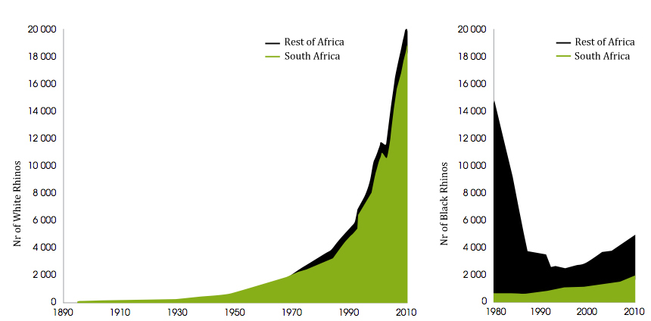
Figure 1. Population trends in White and Black Rhinoceross in Africa, highlighting the population in South Africa (source : Milliken and Shaw, 2012)

The great majority of the population of both species of Rhinoceross (around 98%) are found concentrated in only four countries of the African Continent: South Africa, Namibia, Kenya and Zimbabwe². The figure below shows the historical as well as the recent distribution of the two wildlife species in Africa.
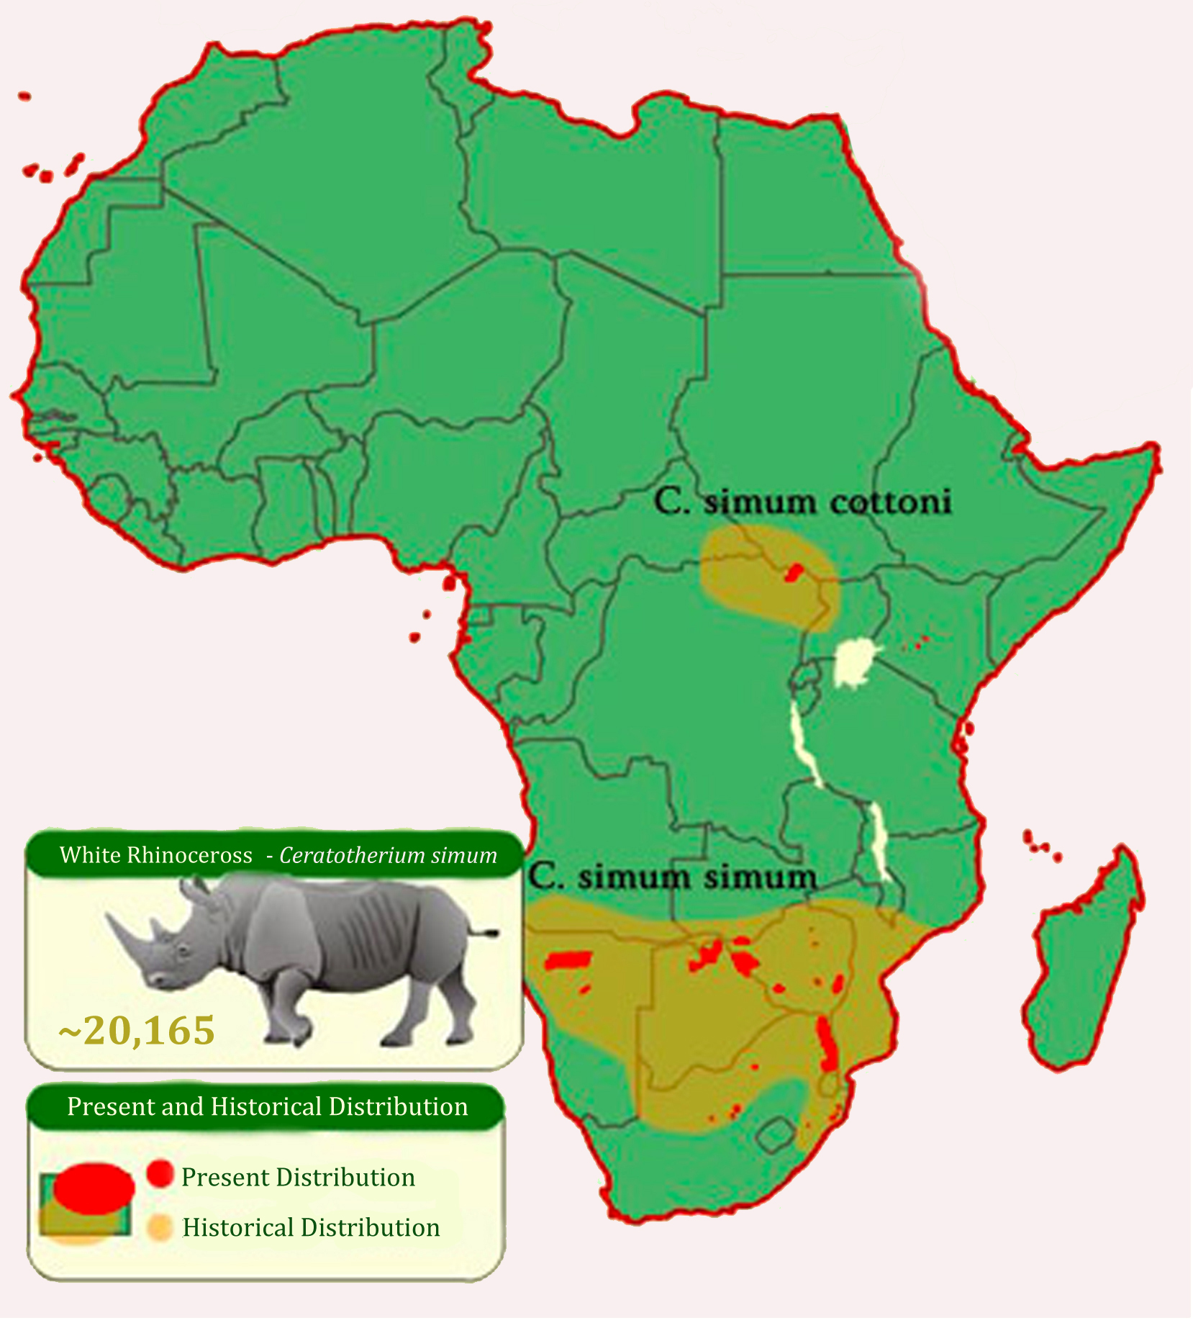
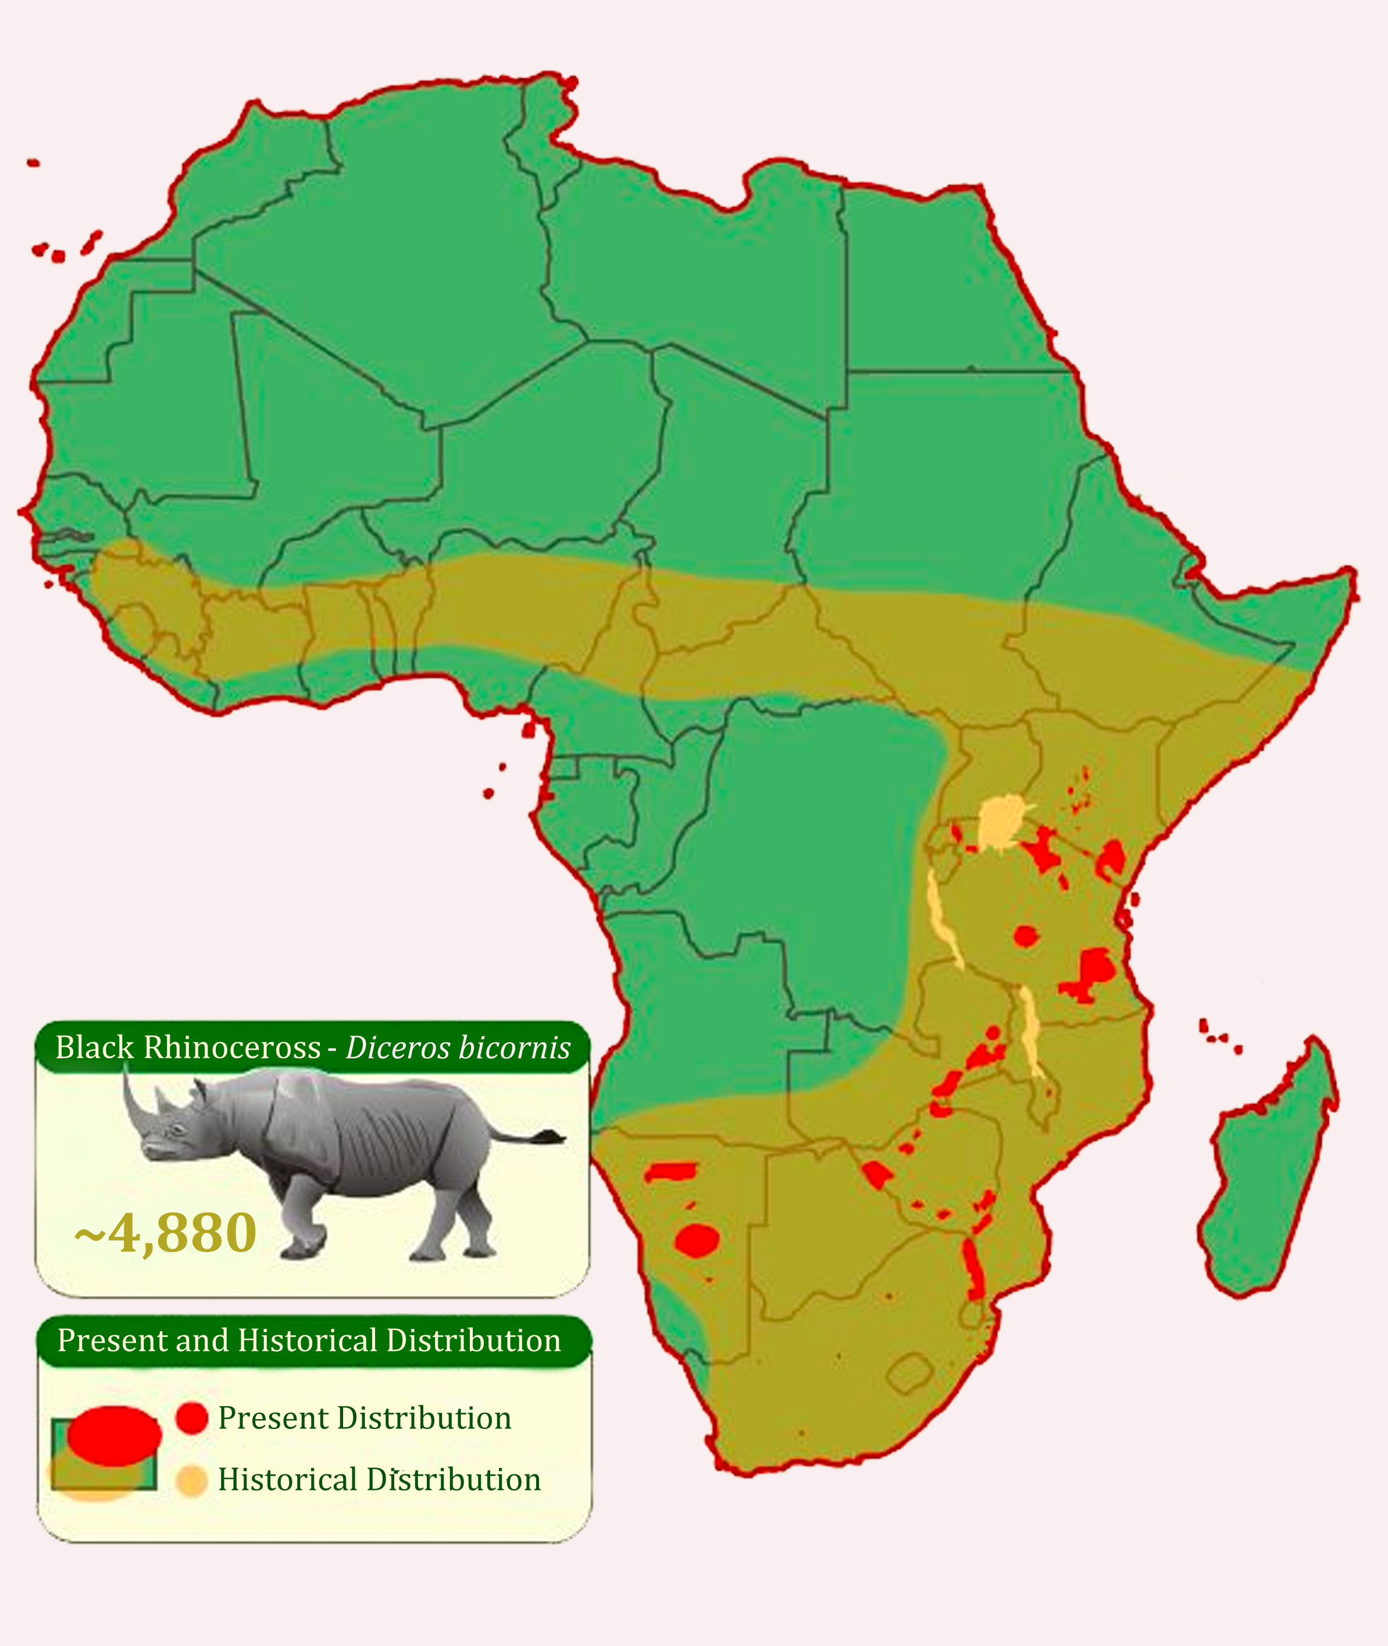

Figure 2. The historical and current distribution of the White and Black Rhinoceros populations on the African continent (adapted from the maps of the do San Diego Zoo⁸).
In Mozambique, historical records confirm the existence of the White Rhinoceros (Ceratotherium simum simum) and Black Rhinoceros (Diceros bicornis minor) ^{9,10,11}. Jorge (2010), conducted a bibliographic review and collected more recent figures on the distribution of the Rhinoceros in Mozambique, especially during the period between 1963 and 1979, and, 2002 and 2009. The study is useful in obtaining an insight on the incidences per District, despite not presenting estimate numbers on the Rhinoceros populations during those periods.
During the 60s and 70s, the White Rhinoceros population was found concentrated in the southern region of Mozambique, especially in the Provinces of Gaza and Maputo, along the South African borders¹². The Black Rhinoceros was scattered along the Central and Northern areas of the country, there were records of them in the Provinces of Sofala, Manica, Tete, Zambézia, Cabo Delgado and Niassa¹³. As far back as the 70's, hunting (legal and illegal) placed great pressure on the Black Rhinoceros population, leading some experts at the time to believe that this species was already extinct in most parts of the country¹⁴.
The White Rhinoceros population was also a target of poaching, having reached very insignificant numbers in the whole country. During the development of the Grand Limpopo Transfronteir Park Project, 12 White Rhinoceross from the Kruger National Park, South Africa, were brought into the Limpopo National Park. Currently, with the exception of ocasional cases along the border with the Kruger National Park, where some animals cross over to Mozambique, there are no more Rhinoceross in the country. One can affirm that the Black and White Rhinoceros populations in Mozambique are extinct. The figure below projects how the White and Black Rhinoceros populations have decreased in the last 50 years.

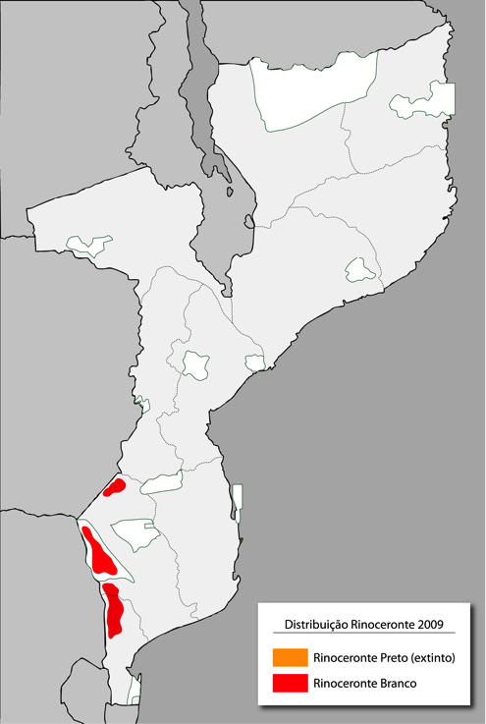
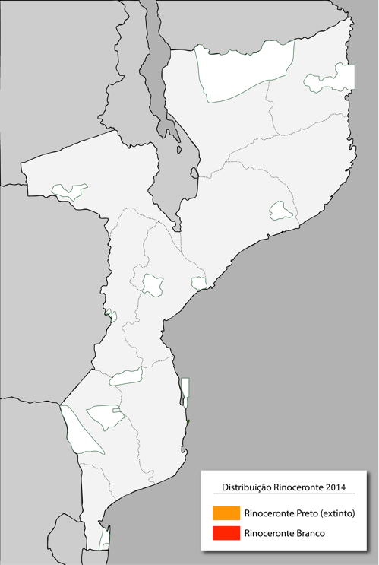
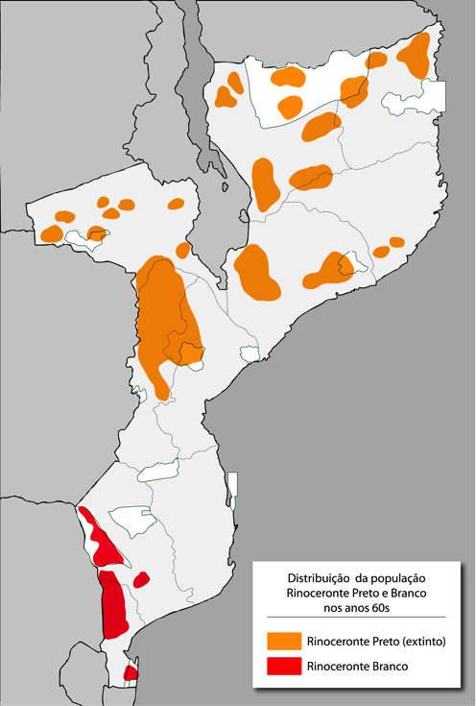

Figure 3. A projection of the distribution of Black and White Rhinoceros in Mozambique along the decades (adapted from the work of Jorge, 2010).
International Union for the Conservation of Nature classification

The IUCN ranks, in the Red List of Threatened Species classifies the status of the White Rhinoceros as "almost threatened", which signifies that it is most likely to be included in the threatened category in the near future. The Black Rhinoceros is classified as "in critical danger", which means that it runs an extremely high likelihood of extinction.

Trends in poaching
The demand for Rhinoceros horns has resulted in an alarming increase in poaching numbers in Africa, especially in South Africa. The demand comes from Asia, particularly from Vietnam and possibly China^{15,16} where Rhinoceros horns are considered to be a symbol of power and wealth and an ingredient in traditional medicine that supposedly cures various illnesses from headaches and fevers, to hallucinations and cancer¹⁷. With the increase in wealth in Asia, the price of Rhinoceros horns has soared, having reached a figure of more than US$60.000 per kilo in the Hong Kong and China markets^{6,18}.
From 2006 to 2012, at least 4.000 Rhinoceroses were reported as being illegally poached in 11 to 12 African countries where Rhinoceroses are found. About 95% of these cases took place in South Africa and Zimbabwe, countries which are considered to be the epicentre of Rhinoceros poaching activities in Southern Africa^{16,19}.
Since 2009, South Africa, with the largest percentage of Rhinoceroses in Africa and in the world, has recorded a alarming, incomparable and ever-increasing figures in Rhinoceros poaching.

Figure 4. Number of Rhinoceroses illegally killed in South Africa during the period 2000 to 2013 (source : South African Department of Environmental Affairs²⁰).

The Kruger National Park, hosting the largest populations of White and Black Rhinoceroses in South Africa, has been the main target of Rhinoceros poaching. Until 2013, around 60% of all the Rhinoceros deaths registered occurred in this South African Conservation Area¹⁶. Poaching levels have increased on an annual basis, even with the level of response that the South African Government has been investing. Some of the measures that have been implemented in the Kruger National Park are :
- increase in number, training and conditions of Law Enforcement Officials (about 300 scouts²²), including placing officers of the South African National Defence Force (around 265 soldiers^{23,24}), and improved equipment (use of helicopters which are well equipped with night vision, use of cybertrackers and unmanned aerial vehicle (UAV) or drones (aircrafts)).
- a revised judicial system, placing more severe penalties, and increasing the courts efficiency in processing cases related to Rhinoceros crimes, and
- a strong public awareness campaign.
The concern in securing the Rhinoceros populations in the South African National Parks has been spread out to other transfrontier regions, for example, the Tembe National Park. This Park borders with the Maputo National Reserve in Mozambique, and has also been a target of illegal poachers coming from Mozambique. Recently, the Park also reinforced its law enforcement force capacity by incorporating soldiers from the Durban Infantry²⁵.
Even with an almost extinct Rhinoceros population, until 2012, Mozambique was seen as the African country with the fourth largest number of illegally killed Rhinoceroses throughout the continent. Recent cases involving Rhinoceros killing involved animals who ventured into crossing the border of the Kruger National Park into Mozambique^{2,26}.
Country | 2006 | 2007 | 2008 | 2009 | 2010 | 2011 | 2012 (September) | Country total
South Africa | 36 | 13 | 83 | 122 | 333 | 448 | 425 | 1,460
Botswana | 0 | 0 | 0 | 0 | 0 | 2 | 0 | 2
Congo | 0 | 0 | 2 | 2 | 0 | 0 | 0 | 4
Malawi | 0 | 0 | 0 | 0 | 0 | 0 | 1 | 1
Mozambique | 0 | 9 | 5 | 15 | 16 | 10 | 12 | 67
Namibia | 0 | 0 | 0 | 2 | 2 | 1 | 0 | 5
Kenya | 3 | 1 | 6 | 21 | 22 | 25 | 12 | 90
Swaziland | 0 | 0 | 0 | 0 | 0 | 2 | 0 | 2
Tanzania | 0 | 0 | 2 | 0 | 1 | - | 0 | 3
Uganda | 0 | 0 | 0 | 0 | 0 | - | 0 | 0
Zambia | 0 | 1 | 0 | 0 | 0 | 0 | 0 | 1
Zimbabwe | 21 | 38 | 164 | 39 | 52 | 35 | 13 | 362
Total | 60 | 62 | 262 | 201 | 426 | 523 | 463 | 1,997

Figure 5. Minimum number of illegally killed Rhinoceroses in Africa during 2006 and September 2012 (figures taken from AfRSG, TRAFFIC and CITES Rhinoceros Working Group²).
Recently, Mozambique has emerged as one of the main sources of poachers operating in South Africa². As an example, in March 2013 alone, the Kruger National Park recorded at least 72 cross-border raids from Mozambique, which were linked to poaching²⁷. An article published in the Sunday Times, 20th April 2014, shows the villages of Massingir, Mapulanguene, Magude and Kabok as being the main points from where the Rhinoceros poachers expeditions depart from.

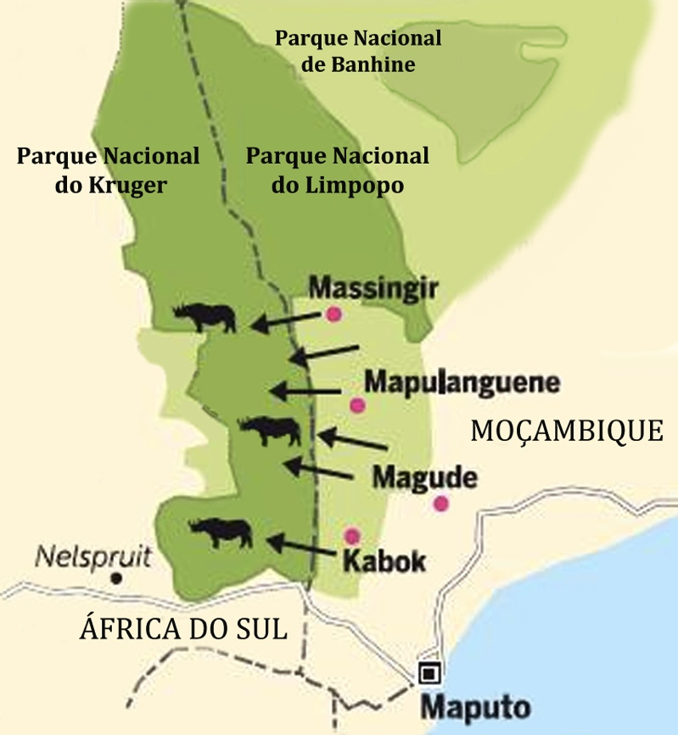

Figure 6. Main routes used by the Mozambican poachers to enter the Kruger National Park in South Africa. (adapted from the Sunday Times, 20 April 2014).
The Rhinoceros poaching operations are very well organized and structured, with individuals running these operations both from within the Limpopo National Park as well as in the village of Massingir. These individuals are locally referred to as 'bosses', some of which allegedly report even to other 'bosses' based in Maputo City. It is usually these individuals that recruits the team of poachers, provides weapons and sells the Rhinoceros horns to buyers from Maputo.
In the Sunday Times article referred to above, the journalist presents information from an interview with one of the 'bosses', who boasts as being one of the richest men in the village of Massingir and who affirms that most of his money comes from Rhinoceros poaching. The article includes a picture of a lodge that he is busy constructing with the poaching money. The lodge has 26 rooms, a restaurant and a terrace pool.
The group of poachers that jump the border to hunt the Rhinoceros usually consists of 3 people - a professional shooter and the other two are batters and carry the axe and the food. For this operation, the shooter receives around 1.500.000,00 Mtn and the others about 750.000,00 Mtn each. They usually receive a deposit from the “bosses” before starting this operation, therefore they are under great pressure to get results²³. The monetary rewards are very attractive, especially bearing in mind unemployment levels in the region. An average employee in Massingir, depending on his/her qualifications and kind of work, earns a monthly salary between 4.000,00 and 5.000,00 Mtn. Therefore, in just one night a poacher earns the equivalent of a cumulative salary of twelve year's of a legal formal worker.

Illegal hunting attracts young people between the ages of 18 and 35 years. They get used to receiving huge quantities of money, quickly, and learn how to establish and operate within criminal networks. This may lead to highly complex social issues as they may enter into other criminal activities in the future, as they would have already established the networks to access, transport and sell illegal goods.
Poacher operations are highly dynamic, and they have the ability to easily change their strategy in order to be ahead of law enforcement operations. They often use the money to corrupt officials and obtain the necessary information where and when needed²⁸. In one of the private areas in the south of Massingir an individual was found walking in the bush carrying around 1 million Meticais in his pocket²⁹. This value was believed to be what he needed to create a network of accomplices.
The way in which the poachers operate lead to believe that there are very well organized syndicates in existence, who have access to equipment that is of high calibre and well maintained. The number of weapons seized has increased, and the type of weaponry used has changed (see figure 7). In the last years, a lot more AKM-47 than Mausers have been apprehended, and there has been an increase in the number of high calibre weapons (e.g. 375 and 458), most of which are in good shape, giving the perception of being either new weapons or well maintained. The weapons are usually hired to brigades of poachers for amounts between 60.000,00 Mtn and 90.000.00 Mtn³⁰. The origin of the weapons is also of great concern, given the fact that many of the them are linked to security and protection officers. One of the weapons of the Massingir was captured three consecutive times in poaching activities in the Limpopo National Park³¹. In July 2013, 3 officers of the Mozambican Republic Police of the Magude village were found guilty of facilitating access to weapons and were indicted for their involvement in Rhinoceros poaching activities³². In September 2013, two months later, again in the village of Magude, the Police arrested 6 poachers with weapons of calibre 458, which had been given to them by a Border Guard officer, who confessed that he had obtained it from a former fighter³³.

Figure 7. Number of weapons apprehended by the Limpopo National Park during the period 2008 and March 2014 (figures provided by Limpopo National Park).
Newspaper articles have revealed various cases of interaction and involvement with Border officials and the Mozambican Republic Police. At the beginning of this year the entire Massingir Police Unit was changed as a result of its involvement in poaching activities. Some of the Game Farms South of Massingir that previously cooperated with the Border Guard and the Police in law enforcement activities, are now avoiding joint operations due the degree of corruption and involvement of many agents in poaching activities.
In addition to these cases of some officers being directly involved in illegal affairs, there is also a need to reinforce the security and compliance system with a public order. In December 2013, there was an attempted burglary of the safe in Limpopo National Park. During the burglary, the criminals killed one of the guards. The case was taken up to the District Police but, until the date of this study (i.e. in 6 months), no investigation has been started. In addition to this situation, in March 2014, a Limpopo National Park car was stoned, and three guards were brutally attacked by members of the Makanduzulo community (a village within the Park), when returning from a patrol operation. Despite the case been exposed there has been no response from the Mozambican Republic's Police, which creates a sense of the impunity of the law.
Involvement in the poaching activities also affects the staff of the Limpopo National Park. Recently, senior officials of the Park were removed due to their involvement in poaching activities, and, it is believed that there are a lot more scouts and senior officials involved³⁵.
Mozambique is thus emerging as a profitable entrepot for the export of illegal horns to Asian markets². Although there are poor statistics, it is believed that an increasing number of Rhinoceros horns are leaving Mozambican ports, including via the International Airport of Maputo and Beira, and pass through other places such as Nairobi (Kenya) and Addis Ababa (Ethiopia) before arriving at its destination in Asia². In 2013, 20 Rhinoceros horns were seized at Maputo International Airport, and, 6 in the first quarter of 2014.
Year | Date | Seized goods | Details of place seized
2009 | 14 July | 2 Rhino horns, 300kg ivory | Mozambique | Seized in Kenya, destination Laos
2010 | 25 December | 19,5kg ivory | Mozambique | Seized in Kenya
2011 | 5 January | 435kg ivory | Mozambique | Seized in Thailand, destination Laos
2012 | 30 May | 7 rhino horns | Maputo International Airport
2012 | 6 June | 25kg ivory | Maputo International Airport
2012 | 7 September | 6 rhino horns | Mozambique | Seized in the Phillipines, found in bags of cashew nuts
2013 | 6 January | 6 rhino horns | Mozambique | Seized in Vietnam
2013 | January | 6 rhino horns | Mozambique | Seized in Thailand, destination Vietnam
2013 | February | 8 rhino horns | Found on a Mozambican in the Niassa Province
2013 | 24 February | 6 rhino horns | Maputo International Airport, destination Vietnam
2013 | 6 April | 8 rhino horns | Maputo International Airport
2013 | 2 June | 6 rhino horns (pieces) | Maputo International Airport
2013 | 7 June | 6 rhino horns (pieces), 40 ivory bracelets, 40 tusks, 40 lion claws
2013 | 19 June | 267 ivory bracelets | Maputo International Airport
2013 | 23 June | 105 ivory artefacts | Maputo International Airport
2013 | 7 August | 6 rhino horns | Mozambique | Seized in Thailand
2013 | 6 September | 4 rhino horns, 54 ivory bracelets , 5 pieces of ivory , 51 ivory necklaces
2013 | 17 September | 5 rhino horns | Mozambique | Seized in Kenya, destination Hong Kong
2013 | 20 September | 2 rhino pieces | Maputo International Airport
2013 | 20 September | 7 rhino pieces | Maputo International Airport
2014 | 16 January | 8 rhino pieces | Mozambique | Seized in Singapore, sentenced to 15 months imprisonment
2014 | 28 January | 1 rhino horn | Mozambique | Seized in Kenya, fined 170,500 euros by Kenyan Court
2014 | 29 March | 3 rhino horns | Maputo International Airport
2014 | 1 April | 3 rhino horns | Maputo International Airport

Figure 8. Some of the figures of Rhinoceros horns and ivory seized in Mozambique and other countries (source from Mozambique) in the last years^{36,37,38,39,40,41,42,43,44,45}.
It is estimated that about 4.063 Rhinoceros horns have been illegally exported from Africa during the period 2009 to September 2012². Despite raised awareness on the issue, the capacity to detect and recover the horns has been reducing, from 68% in 2001 to 5.2% in 2012¹⁹. This downfall coincides with a increased involvement of organized crime syndicates in this activity².
These current trends in Rhinoceros poaching are not sustainable and may reverse all the conservation work done in the last decades, thereby placing the White and Black Rhinoceros populations in serious risk of extinction on the Continent².

The Elephant

Distribution and numbers
The African Elephant (Loxodonta africana) is the biggest terrestrial mammal in the world, and lives in various habitats in the African continent, from forests to savannahs to desserts. Currently, the African Elephant is found in only 37 countries of Sub-Saharan Africa⁴⁶. Recent statistics on the African Elephant estimate the African Elephant population to be between 419.00 and 650.000⁴⁷.
The Southern African region is the only region that has shown a relatively stable elephant population, with even some growth in some parts⁴⁸. Other regions have revealed a very disturbing situation, where the elephant population has decreased, for example, in Central Africa where there is an estimated decrease of around 60% in the number of elephants in the last 10 years^{49,50}. The Southern African region, with around 55% of the population, contains the largest majority of the population; 28% in Eastern Africa, 16% in Central Africa and less than 2% in Western Africa⁵⁰. In Southern Africa, Botswana has the largest elephant population of the region, with around 133.088 estimated in 2012⁵¹.

International Union for Nature Conservation (IUNC) Classification

The IUCN, considers the status of conservation of the African Elephant as "Vunerable" on the Red List of Threatened Species⁵². This signifies that the evidence leads one to believe that the species is in high risk of extinction, especially given the levels of reduction in the size of its population and its coverage area⁵³.

In 2008, the Mozambican Ministry of Agriculture funded an aerial count of the wildlife species throughout various areas of the country, with a sampling rate of 2.35%. This study combined the results of recent estimates from previous counts from areas that were not included in the study (for example, the Niassa National Reserve and the Magoè District). This count estimated the Elephant population in Mozambique to be around 22.000⁵⁴. In 2010, the National Management Plan for the African Elephant was approved, it estimated the Elephant population to be around 20.000.
Using the information available in the above studies, the 2009 Ntumi et al study, and more recent counts, it was possible to calculate a more recent estimate of the Elephant population in Mozambique. Data from the following areas was used: Maputo National Reserve, Limpopo National Park, Gorongosa National Park, Chimanimani National Reserve, Coutada 9, Marromeu National Reserve, Tchuma Tchato, Gilé National Reserve, Quirimbas National Park, Quirimbas-Niassa Corridor, Niassa National Reserve, the region south of the Niassa Reserve, and Chipange Chetu. Although the data does not allow for a complete and precise estimate, the total number of Elephants in Mozambique until 2011/2012 was calculated at around 22.300. The graph below shows the trends in the country's elephant population during 1974 and 2011.

Figure 9. An estimation of the elephant population between 1974 and 2011 (adapted from Ntumi et al, 2009, with more recent data from aerial counts).
Although about 70% of the elephant population is found in only two areas of the country (the Niassa National Reserve with about more than half of the country's elephant population, and the Mágoè District), the elephant population distribution is fragmented throughout the country in about six sub-populations located in the following regions^{54,55}.
i. Maputo National Reserve;
ii. The area South of the Inhambane Province;
iii. The Limpopo River and the areas bordering with Zimbabwe;
iv. The Zambezi Valley in the Tete Province up to the centre of the country;
v. The North of the country; and
vi. Gilé.
The knowledge and existence of limited data and subjective opinions ultimately influence the estimates of the distribution and densities of the elephant in the country. There are few studies and available data on the movement and dynamics of the country's elephant population. It is a known fact that elephants are a species that travel long distances, very often moving outside the boundaries of the conservation areas and the countries. The following figure 10 is based on the distribution map of the elephant by Ntumi et al (2009), adjusting the boundaries based on the information in the more recent counts (where available), and adding an estimate of its density. On the map it is possible to note the transboundary tendency of the species, in the regions of Maputo National Reserve, Limpopo Park, Tete Province and the Niassa National Reserve.
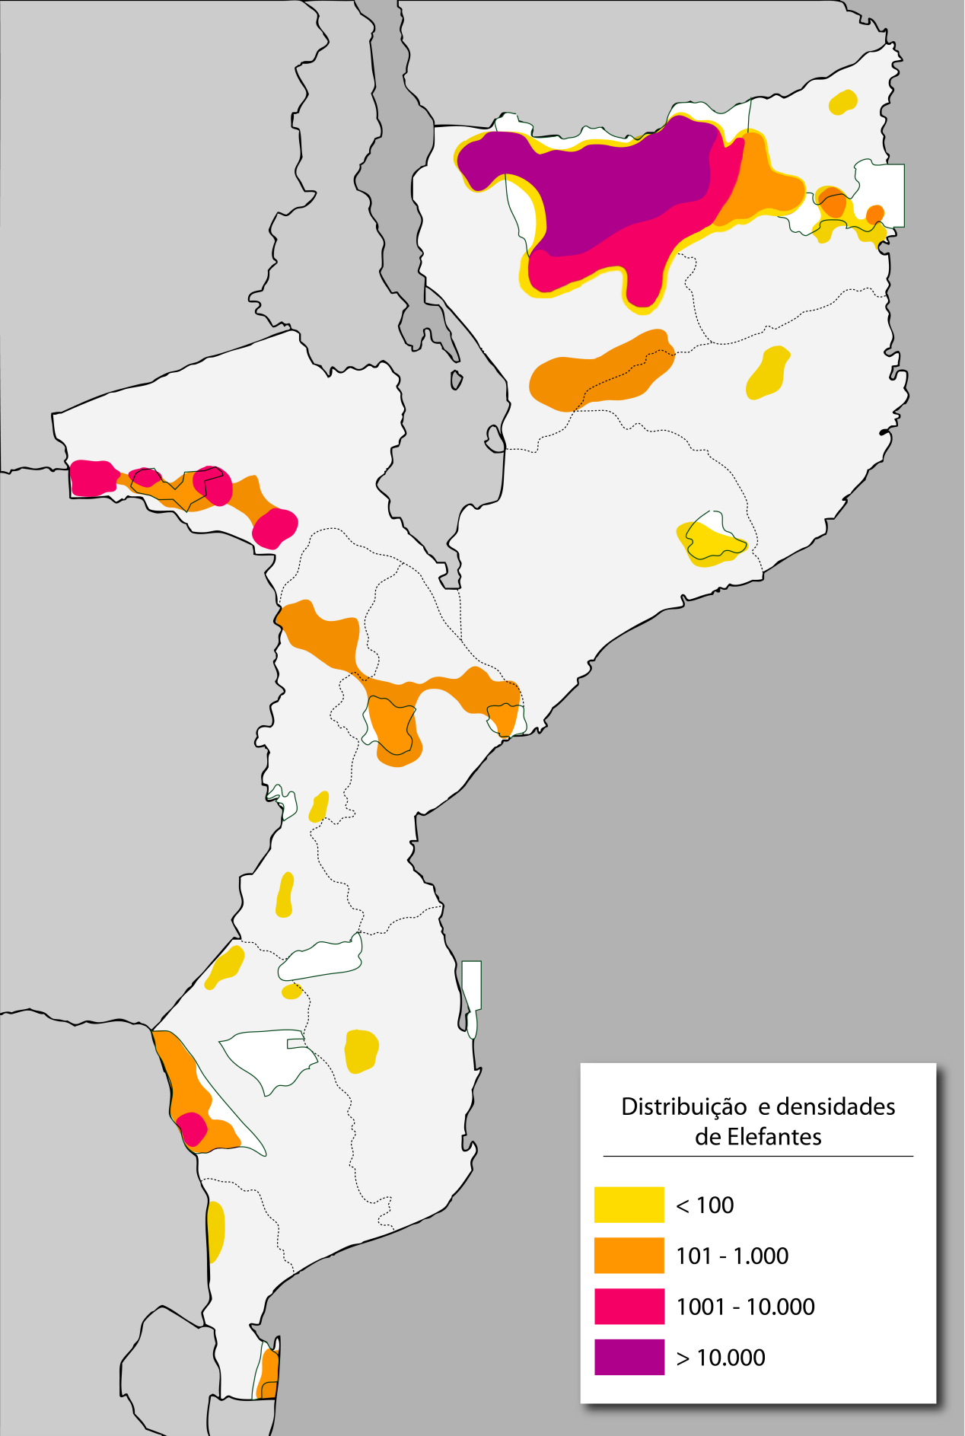``
Figure 10. Estimate of the distribution and density of the elephant population en 2011 (adapted from Ntumi et al 2009, with more recent data from aerial counts).
The need for further studies as well as the availability and processing of existing information is crucial. The ideal would be for a competent entity to collect information on the distribution and population of Elephants at frequent intervals, using appropriate and standardised methods and well trained observers. This would allow for the reduction of various uncertainties on the distribution and densities of the Elephants, helping to achieve more realistic and well - focused strategies.
With this in mind, it is important to refer to the elephant population count on the whole of the African Continent, that began in February 2014. This project, financed by the Paul G. Allen Foundation and led by the organization Elephant Without Borders, will run for about two years and hopes to provide accurate data on the numbers and distribution of the African Elephant population on the Continent. In principle, the project will also cover Mozambique, an operation that will be coordinated by the Wildlife Conservation Society (WCS) in partnership with the Government of Mozambique, thereby constituting an excellent opportunity to obtain information that will benefit the various conservation efforts.

Poaching trends
The African Elephant has been a target of an increasing wave of poaching, largely in order to obtain its ivory tusks for ornamental purposes for the Asian markets, especially China.
Since the implementation of the MIKE programme (Monitoring the Illegal Killing of Elephants) in 2001, the year of 2011 recorded the highest level of poaching. It is estimated that about 7.4% of the whole African Elephant population throughout the Continent was illegally killed. This figure represents a number of about 17.000 elephants⁴⁸. The natural growth rate of the elephant is around 5 to 6%, therefore, the percentage of illegal killings recorded in 2011 is well above sustainable levels of loss. This means that in case the current trends in elephant poaching are not reverted, it may lead to great losses of the elephant population on the continent⁴⁸.
The MIKE Programme
With the objective of being able to monitor the illegal killings of elephants, in its 10th meeting in 1997, the Parties Conference, established the MIKE programme (Monitoring the Illegal Killings of Elephants). This programme is managed by CITES Secretariat and implemented in collaboration with IUCN. The MIKE programme intends to improve the management of the elephant population by monitoring the trends in the levels of illegal elephant killings, and the factors associated with these trends. There are around 60 areas registered on the MIKE programme, covering about 31 African countries.

The MIKE programme evaluates hunting levels making use of PIKE (Proportion of Illegally Killed Elephants), which calculates the number of elephants found illegally killed divided by the number of elephant carcasses found. PIKE figures then vary from 0.0 (all the carcasses found are from elephants that have died naturally) to 1.0 (all the carcasses found are illegally killed)⁴⁸.
Despite PIKE figures reflecting an indication of poaching trends, the results should be carefully interpreted. The figures may be influenced by a number of related factors, for example, the quality of data and the probability of identifying the carcasses^{48.}
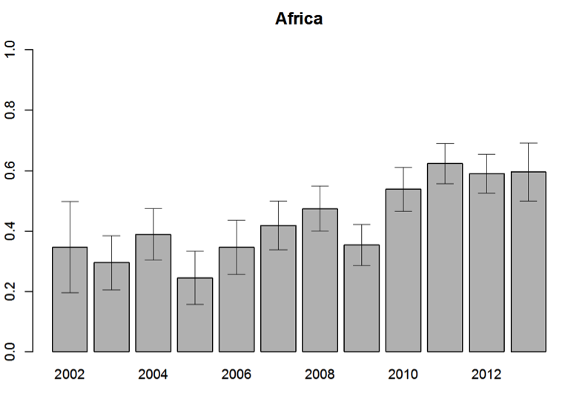

Figure 11. Estimated figures by PIKE for Africa for the period 2002 to June 2013. (source: CITES, IUCN, TRAFFIC, 2013).

The levels of African Elephant poaching vary according to the Continent's regions; Central Africa has recorded the highest rates, while East Africa has recorded the highest number of carcasses. Despite the differences, there is an apparent increase in the PIKE figures for all the four regions of Africa.
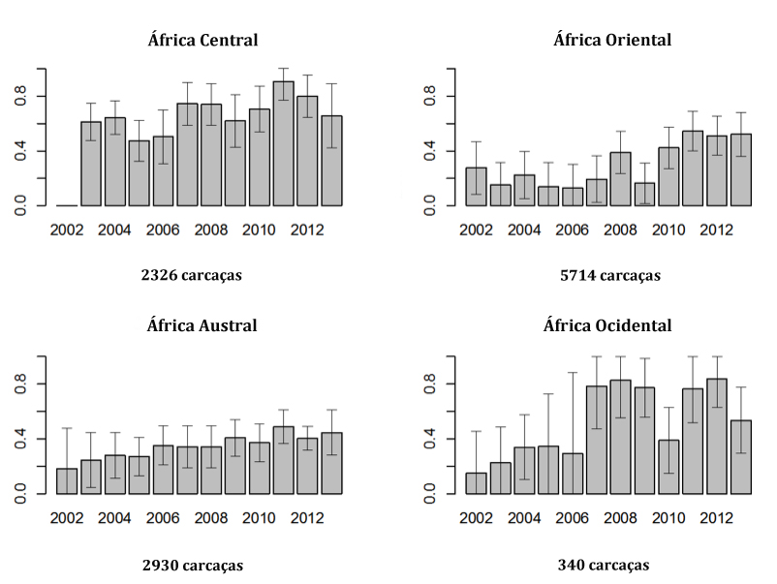

Figure 12. PIKE values of the four regions in Africa (source CITES, IUCN, TRAFFIC, 2013).
The map that follows shows the PIKE values for 2012 for the MIKE areas of Africa. Mozambique has two MIKE areas, that are the Niassa National Reserve and the Mágoè District in the Tete Province, both of which have been registering high PIKE values over the last years (Niassa: 0.33 (2006), 0.88 (2008), 0.84 (2010), 0.89 (2011); Tete: 0.58 (2010), 0.83(2011))².
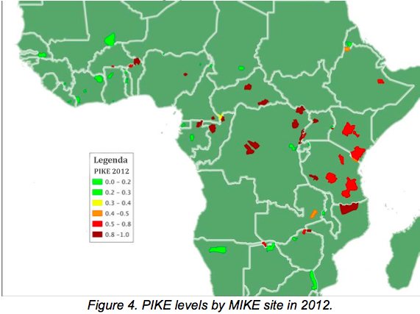
Figure 13. Map with PIKE values for 2012 for the MIKE areas in Africa (source: CITES, IUCN, TRAFFIC, 2013).
These two areas are the regions of the country that contain the largest elephant population in Mozambique. One of the particularities shared between Mágoè and Niassa is its transboundary nature, which ends up translating in illegal movements between countries, especially given the susceptibility of the porous borders.
In the Mágoè District (as well as in the Zumbo District), there are records of ivory being hidden between bags of fish and transported in open vans to Zimbabwe and Zambia⁵⁵. In 2010, around 12.8% of elephants estimated to be in the Mágoè District were carcasses⁵⁷. The figure below shows the distribution of carcasses that were registered on an aerial count; there is an high concentration in the area west of the District, next to the Zimbabwean border. It needs to be noted that no fresh or recently killed (killed in the last year) carcasses were spotted during the aerial count. This does not necessarily mean that poaching trends have decreased. Sometimes, once killed, the elephants are demembraned and their body parts are removed, therefore, no carcass would be sighted during an aerial count⁵⁷.

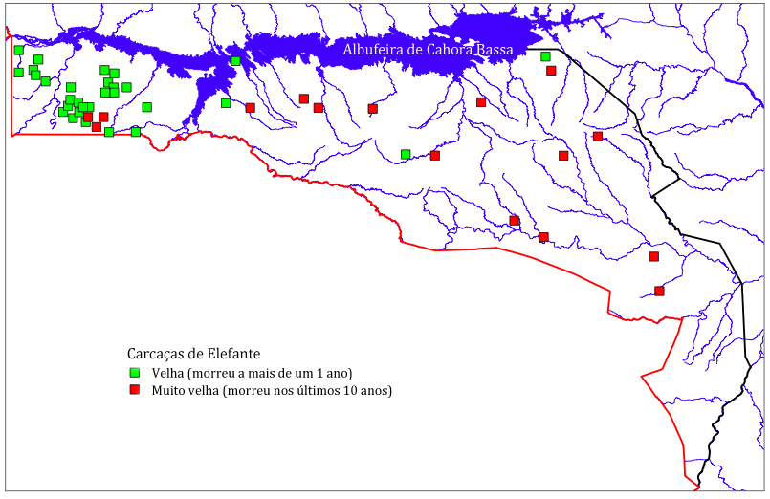
Figure 14. Distribution of elephant carcasses sighted during an aerial count of the area south of the Cahora Bassa dam in 2010 (source : Agreco, 2010).
In 2011 and 2012, the ratio of carcasses found in Mágoè remained high (8.4 and 11%, respectively⁵⁷), jeopardizing the sustainability of the elephant population in this region. Most of these elephant deaths were as a result of poisoning, a practice that is widely used in the Mágoè District. The Zimbabwean poachers make use of toxic substances such as cyanide, which is obtained from the mines in ZImbabwe, to poison elephant waterholes and food⁵⁸. In 2013, half of the carcasses recorded in the MIKE data for the Mágoè District resulted from death by poisoning..
Although there are a few cases of elephants being killed by poison in the Niassa National Reserve, most of the illegal killings are still done by weapons⁵⁹. PIKE data from 2011 for the Niassa Reserve is very high. Of the 85 carcasses that were registered, 75 had been killed illegally⁶⁰.
The rate in elephant poaching has escalated substantially in recent years, especially since 2009⁶¹. The biannual aerial counts that have been conducted since 1998 allows for the monitoring of the trends in the wildlife population, as well as to record the occurrences in which elephant carcasses are found and other legal activities. The graphs below show the trends in the estimated elephant carcasses and the estimation of bull elephants found in the Niassa Reserve during the period from 1998 to 2011. The trends confirm a significant increase in the estimated number of carcasses found since 2009. The data also reveals a decrease in the estimated number of bull elephants, thus confirming that the male elephant is in greater demand as their tusks are larger.

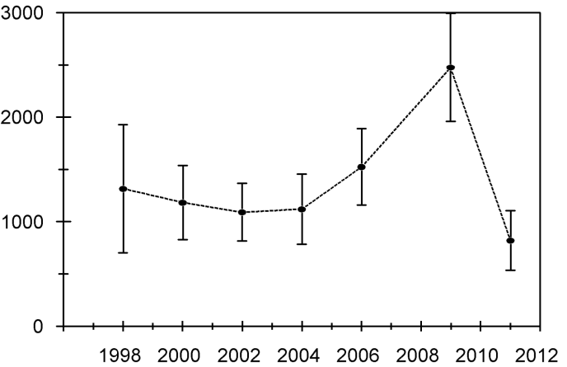
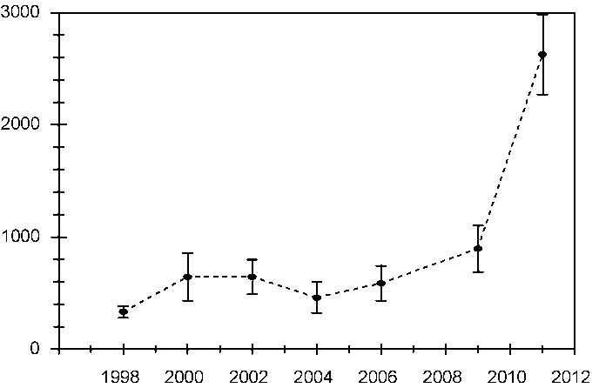

Figure 15. The graph on the left shows the trends in estimated elephant carcasses during aerial counts between 1998 to 2011; the graph on the right shows the trends in estimated bull elephant numbers during the aerial counts between 1998 and 2011. (Source :Craig, 2012).

Based on the aerial counts in the Niassa Reserve between 2009 and 2011, the estimate of carcasses has tripled, from 756 to 2.365 respectively^{62,63}. Not only was there an increase in the number of carcasses but also in the way in which the elephants were being killed, suggesting the involvement of very experienced poachers⁶¹. This growing trend has been maintained; in the first quarter of 2014 alone, an estimated 225 elephant carcasses have been found in the Niassa National Reserve, all as a result of illegal killings⁶⁴.

The majority of elephant poaching incidents take place in the area between the Rovuma and Lugenda Rivers, near the border with Tanzania. The relations between Niassa and Tanzania are historical; there are strong family and economic ties between the people that live on both margins of the Rovuma River^{24,61}. Today, there are still various pedestrian paths that one can cross from the interior of the Niassa Reserve to the other side of the border. This close relation with Tanzania has granted various professional poachers easy access into the Reserve.

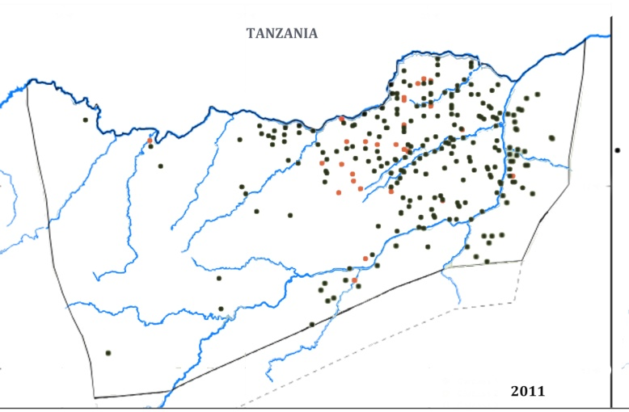
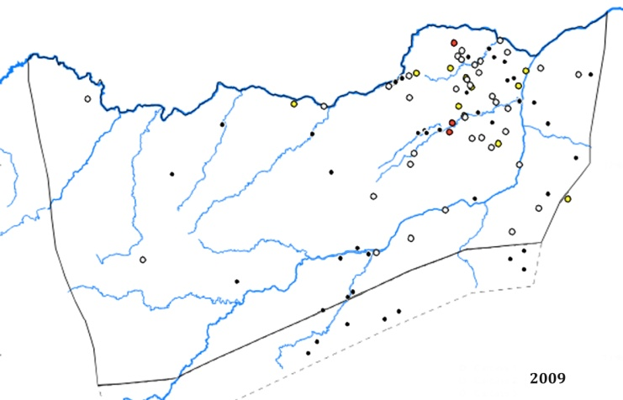

Figure 16. The Map on the left shows the distribution carcasses sighted on an aerial count in 2009. The map on the right shows 2011 figures. (Source: Craig, 2009 and Craig, 2012).
Some members of the local community have not only supported the poachers by providing them with shelter, but they have also become involved in elephant poaching activities. In 2012, in the village of Mussoma, within the Niassa Reserve, two members of the community were caught involved in elephant poaching. One was the leader of the Mussoma community, who was found with 18 high calibre bullets (.375 and .458), and the other was a village resident that was caught hunting an elephant with the Secretary of the Frelimo Party of Mecula⁶⁵.
In 2010, an interesting case was reported at the Niassa Reserve⁶¹, which revealed the corruption in the system and the connivance between community members and members of the Police. The case began in April 2010, when two poachers were arrested for operating in the Nalama area. They were found with three firearms (one being a AKM-47 which had been hired from a Police agent of Montepuez for 15.000,00 Mtn), ivory tips and elephant tails. The poachers and the firearms were referred firstly, to the Police of Mecula, then to Marrupa. A month later, the Reserve scouts were shocked to see that one of the firearms that had been apprehended, being used by officials of Mecula Disctrict SDAE. This involvement of weapons from the Border Guards and from the Police in poaching activities is concerning, and various situations have already been previously reported just in Niassa Reserve⁶¹.
One of the most alarming cases happened in December 2011. Eight Border Guards were transferred to another part of the country after being caught selling 350 Kg of ivory to Tanzanians citizens within the Reserve⁶⁶. Similar situations occurred in the subsequent years. Between 2012 and 2013, 11 firearms were seized. These included four AKM-47, three of which belonged to Mecula Police, two semi-automatic firearms, three high calibre firearms (.375 and .458), and more than 600 ammunitions, 95% of which were of AKM-47⁶⁷.
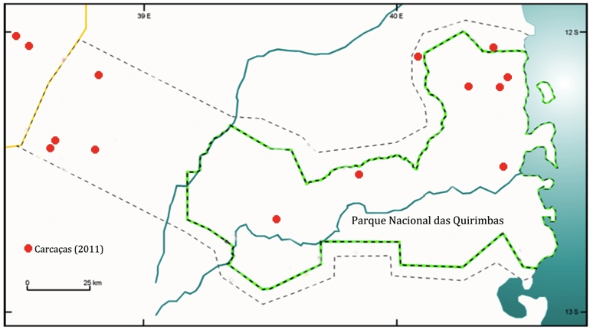
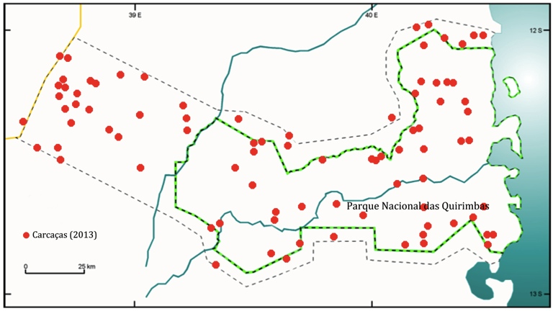
Poaching has also been reported in other parts of the North of Mozambique where there are elephants, i.e. in the region of the Quirimbas National Park. A recent aerial count in 2013 revealed alarming data on the levels of poaching. One in every two elephants sighted by the counting team was a carcass⁶⁸. Compared to the count in 2011, the estimate of carcasses increased from 119 to 811^{68,69}.
Figure 17. Distribution of carcasses sighted in the 2011 aerial count (left map) and in 2013 (right map). (Adapted from WWF maps, 2012 and WWF, 2013).
The operator of the Taratibu concession, in the Quirimbas National Park, reports that in the last two years the poaching attacks have been such, that, it is now rare to see elephants that were common before. Apart from being specialized hunters, and well equipped, poaching happens with the help of the local communities, who are enticed by high monetary values, such as 25.000,00 Mt for simply informing on the animal's location⁷⁰.
The ivory ends up on the Asian market, especially China. Given the amount and weight of the pieces, the majority of apprehensions have been made at the maritime ports, where the goods have been discovered inside containers. For example, in January 2011, in the port of Pemba, a log container, bound for Asia, containing 126 ivory tips was apprehended (i.e. 63 illegally killed elephants)⁷¹. This presents a major challenge for effective law enforcement, bearing in mind that only a small percentage of containers (less than 5%) are actually checked, and the methods for detecting illegal ivory (e.g. risk assessment, use of sniffer dogs, etc) are not routinely used⁵⁰.

The Local Market
Ivory is also found at the country's local craft fairs, especially in the provincial capitals where various products including ivory are sold. In the city of Maputo, the two main fairs are - "Feira do Pau" (a fair that takes place every Saturday at the 25 de Junho Square) and "Feira de Artesanato, Flores e Gastronomia" - FEIMA (Craft, Flower and Food Fais; open every day and situated at the Jardim dos Continuadores). Ivory sculptured pieces, as well as raw ivory tips can be found at both these fairs. The main clients are the Asians, who are interested in both raw (which are polished for a better appearance) or carved parts. These parts are generally not exposed, especially the raw tusks, and are only shown to certain potential clients. The photos below were taken in April 2014 at FEIMA. On the photo on the right both ivory tusks have already been prepared (smooth surface) for selling (the two tusks are being sold for a price of 60.000 Mtn). The source, who requested to be anonymous, revealed that some customers have asked for small pieces as these can be more easily hidden inside a suitcase.
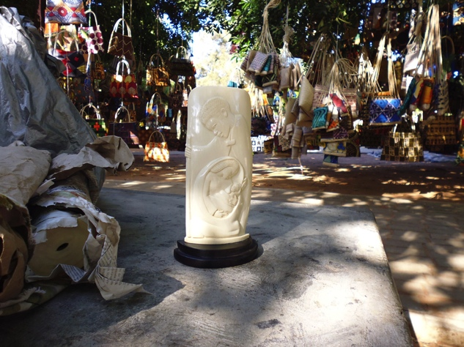
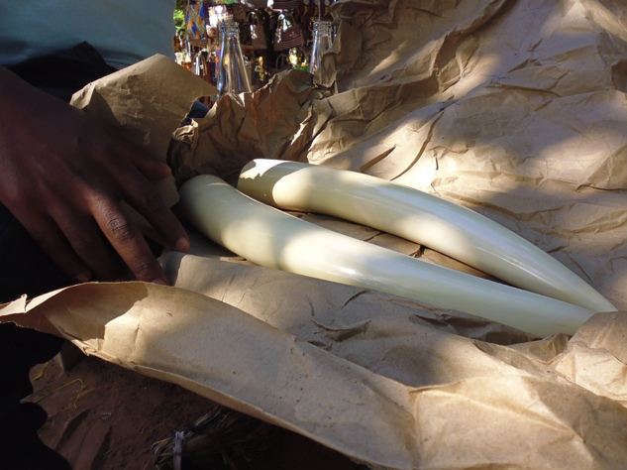

Figure 18. Raw and carved elephant tusks sold at FEIMA (April 2014).
On 19th April 2014, the National Directorate for Lands and Forestry and the Mozambican Republic Police raided the Feira do Pau, and apprehended various ivory artefacts (i.e. 2 ivory medals, 2 ivory sticks, 3 ivory necklaces, 28 ivory bracelets, 24 ivory spoons, 43 ivory forks).

The International Market
Since 2009, China has been the African continent's biggest trading partner¹¹³. This relationship is expected to continue to grow, reaching an estimate of about $365 billion American dollars in 2015 (a value far higher than around $90 billion American dollars in 2009)¹¹⁴.
Despite this trade being valuable for economic growth on both sides, it has also been used to transport illegal products, which has a significant impact on the environment, especially for the wildlife population of the African Continent. Data from recent years shows ivory being exported on a great scale from East Africa to Asia; China being the preferred destination⁴⁸. China has been constantly identified by CITES as being one of the countries that are most involved with the illegal trade of ivory².
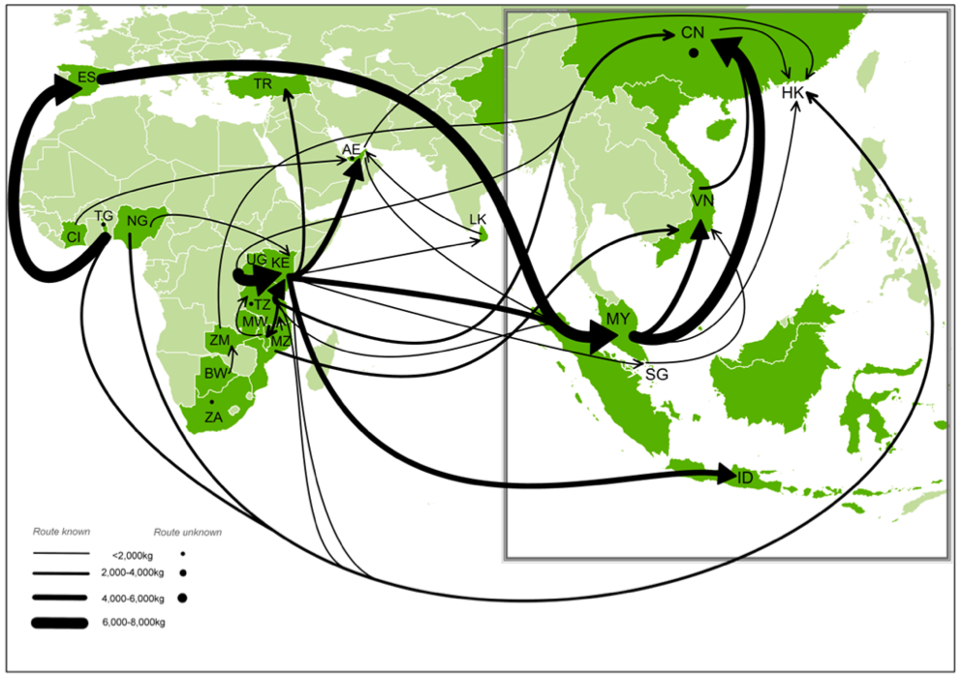
Figure 19. Trade routes used in many apprehensions of illegal ivory 2012-2013 (ETIS, 2013)
The demand on these Asian countries is quite complex, with a variety of markets and a mixture of perceptions by various stakeholders. Although it is important to have an adequate knowledge and understanding of the market demands in order to address the whole issue of illegal trade of wildlife, it is in many cases the misinformed and exaggerated opinions that result in incorrect perceptions about the characteristics of this market. In a recent study on ivory demand by the Chinese conservationist, Gao Yufang, it showed that¹¹⁵:
- the majority of Chinese have never seen or bought ivory. Only about 1% of the Chinese population is involved in the ivory trade, which is still high given the size of the Chinese population.
- most ivory traders are not from the general Chinese middle class, but just from a section of the new rich, less educated and with a taste to exhibit their social status.
- there are different kinds of markets. The 'white' market is more formalized, with shops, offices and factories registered under the Chinese Government. The 'Black' market is dominated by the online market. The 'grey' market involves live auctions, where various ivory items are sold. These types of auction houses have increased exponentially, especially between 2009 and 2011 (the period which coincides with the increase in the demand for ivory in Africa). Towards the end of 2011, the Chinese Government intervened in the market, banning ivory auctions.
- the two principal reasons behind the demand for ivory in China are: i) the official recognition that preserving Chinese tradition has increased the cultural value of ivory artefacts; ii) an investment boom in arts, especially after the stock and property markets depreciation in 2008, which led to other artefacts being sought, and those made from ivory become an alternative profitable investment.
Having better understanding and information on the nature and dynamics of the market helps to converge and better target the interventions by various interested stakeholders in combating illegal wildlife trade. This may also help African countries with their relationship with China via forums such as the China-Africa Cooperation Forum, as well as having access to the $10 million American dollar funds which was recently set up by the Chinese Government to provide the necessary support in order to address the challenge of poaching and illegal trading of ivory.

The Causes
The causes that lead to the increasing levels of poaching and illegal trade are complex and interlinked. The poachers seek meat, ivory, rhinoceros horns and other animal body parts such as nails, skin, tails, etc, and involve many sectors of the community; ranging from local communities, to intermediates in vilalges and city, to Park and Reserve officials and Police Officers.
The MIKE programme produced a statistical evaluation of the relation between the PIKE figures and a diversity of ecological, biophysical and socio-economic factors at a local, national and global level⁵⁰. The three principal factors highlighted were the poverty on a local level, governance on a national level and the demand for ivory and rhinoceros horns globally.
Locally, poaching provides income, and given the levels of poverty and unemployment, facilitates the poachers in recruiting manpower. The theory that the increase in wealth helps reduce poaching has no evidence to support it; it is often proven that an increase in buying power leads to an increase in the demand for illegal products. Nationally, PIKE has a stronger correlation with the governance factor, which is measured by the Corruption Perception Index^{50,} Inadequate governance of the conservation sector on the whole is often seen as the deciding factor. High levels of poaching is prevalent in countries with lower levels of governance, and vice versa⁵⁰. The organizations that are responsible for monitoring poaching and illegal trade suffer great financial constraints, and very often are not able to invest in the necessary resources that are needed to introduce measures to address the current crisis.
According to the parties that were interviewed, some of the principal factors which lead to the increasing poaching and illegal trade levels in Mozambique are :
- Weak valuing of the conservation sector - there is a perception that there is very little sensitivity with regard to the importance of conservation in many sectors of the state; from the highest ranked politician and government official, to other sectors such as the private sector, non-profitable organisations and local communities. This leads to a civil society which is not very active and participative, contributing still in a very limited way towards the conservation sector.

- Weak state law enforcement - Parks and Reserves are understaffed and current scouts do not have the necessary training, equipment or motivation needed.

- Vunerable borders - Mozambique, with its vast border, is considered extremely vunerable as law enforcement and control of citizen movement between the borders is weak.

- Corruption - the principal factor that contributes towards the easy access into areas where elephants and rhinoceros live, the access to firearms, the transport of ivory and rhinoceros horns exiting the country. Corruption and organised crime were some of the principal reasons why Interpol, in an effort to combat poaching and illegal trade in Africa, launched Operation Worthy in 2012⁷².

- Lack of Institutional Coordination - weak coordination and cooperation between different institutions (Ministry of Tourism, Agriculture and Interior) is seen as one of the factors that restricts the conduct of successful operations⁷³. In addition, there are conservation areas (i.e the Niassa National Reserve and the Quirimbas National Park) whose area includes Districts and their respective administration offices, having thus two governance systems for the same resources in the same space, implying the need for a very strict and effective cooperation and coordination in order to avoid conflicts.

- Legal and judicial framework - the legal system did not consider poaching a crime (this fact changed recently with the passing of the new Conservation Areas Law), and was seen simply as a simple infraction, thus not treating the issue seriously. In addition, the sensitivity in which the magistrates dealt with the issue was also seen as a constraint, allowing the poachers to be easily released, so, returning to poaching.

- Poor compliance with Legislation and Plans - despite the legal system having to improve, it is recognized that a lot more can be done if current legislation is properly fulfilled. The correct implementation by the various sectors of Government of the Conservation Areas Management Plans or the Land Use Plans can also alleviate some of the current conflicts that exist with the conservation sector.

- Improvement in communication and connectivity - the opening and improvement of access roads, and the installation of improved communication systems in areas that were previously more isolated, has made the removal of illegal items more profitable. This is also reported as being the case for the Niassa National Reserve, where there have been major improvements on the roads within the Reserve⁶¹.

- Population growth within the Parks and Reserves - the presence of people living in almost all the country's conservation areas is seen as a concern, given the necessary population growth rate. It is estimated that around 250.000 people live in the National Parks and Reserves. Based on the current management models of these areas, it is difficult to accommodate their needs and interest for development. The existing levels of poverty, matched with the perceptions of poor conservation benefits, encourage the community members to become involved in ivory and rhino horn poaching activities.

- Man-Elephant Conflict - the contact between people and dangerous species such as elephants has led to conflict situations which endanger human life and the agricultural produce of the respective local communities. Even though the number of Man-Elephant cases reported are seasonal and relatively low, the conflict results in a reduced appreciation of, and willingness to participate in, efforts to conserve a species such as the elephant. The costs of living with elephants, as well as the benefits of living without elephants, are equally high, therefore, facilitates the connivance and support of local communities in poaching activities.

Some interviewees also mentioned the importance of maintaining a broader perspective on the sustainability of the elephant population in the country, especially with regard to the protection of the habitats. Without the necessary habitats it would not be possible to maintain the wildlife population in the country's conservation areas. With this in mind, the concern raised was to invest not only in interventions that focus on the reduction of poaching levels, but also to address the levels of loss of habitat.

On a trial basis, this study accessed the data from the Global Climate Changes that was published in 2013 by Hansen et al, (accessible on the website), to map the loss of forests within the Niassa National Reserve and the Quirimbas National Park in the last 12 years. The following maps illustrate not only the concerning scale of loss of habitat (about 27.500 hectares lost in the Niassa National Reserve, and about 26.700 hectares in the Quirimbas National Park), but also how it is scattering throughout the country.
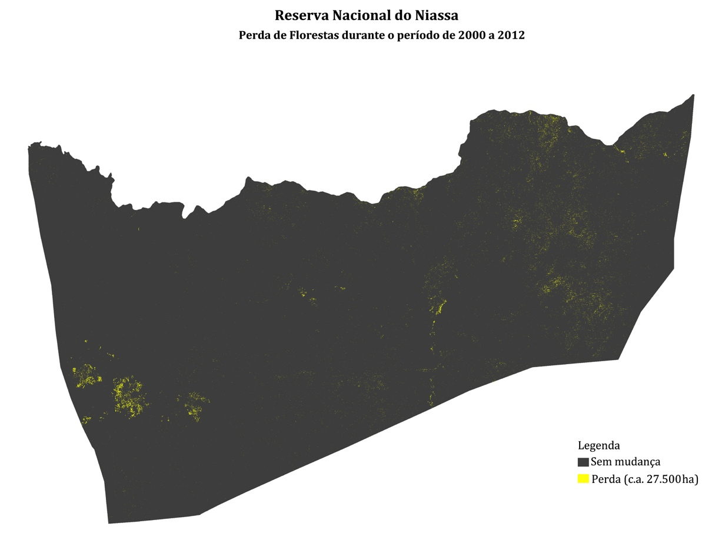Figure 20. Map illustrating the loss of forests within the Niassa National Reserve during 2000 and 2012⁷⁴.
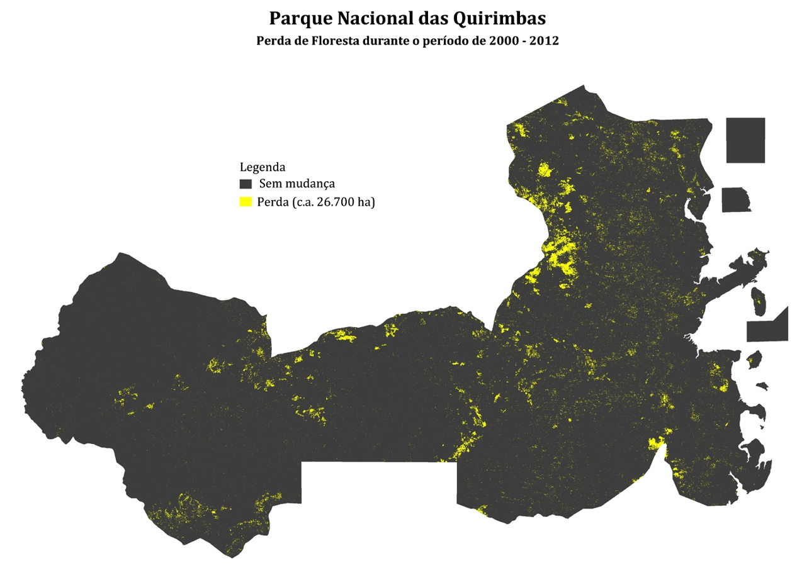
Figure 21. Map illustrating loss of forests in the Quirimbas National Park between 2000 and 2012⁷⁴.

Conventions, Agreements and Programmes

A cooperative approach to the initiatives to curb the current trends of illegal trade and poaching of elephants and rhinoceros is increasingly needed, seeking partnerships and synergies on national and international levels. Various countries have established programmes, agreements and given statements both within their own borders, as well as regionally and globally.
This approach aims not only to strengthen relations and partnerships with various stakeholders involved in fighting this crisis. It is also a way in which the countries publicly commit to their fellow citizens and the society worldwide.
Internationally, Mozambique has participated in some of these important events on this issue, and has committed itself to anti-poaching and illegal trade of wildlife. The table below presents some of the relevant Agreements and Declarations ratified by Mozambique.
Convention / Declaration or Agreement | Year
Convention on International Trade in Endangered Species of Fauna and Flora (CITES) | 1981
United Nations Convention on the Protection of the World Cultural and Natural Heritage | 1982
Convention on Biological Diversity | 1995
United Nations Convention on Transnational Organized Crime | 2006
United Nations Convention against Corruption | 2008
London Declaration on Illegal Wildlife Trade | 2014

Mozambique participated in the following three events recently.
16th Conference of the Parties of CITES
Mozambique attended the CITES' 16th Conference in Bangkok (Thailand), from 3rd to 14th March 2013. During this conference, decisive actions were taken to deal with the concerning trends in the levels of poaching and illegal trade of the African Elephant and Rhinoceros.
The African Elephant Summit
In December 2013, Mozambique attended the African Elephant Summit in Gaborone, Botswana, and assumed commitment and political support in ensuring the implementation of the urgent measures that were approved under the African Elephant Action Plan at the CITES 15th Conference of Parties. The Summit agreed that 14 urgent measures needed to be implemented by the signatory countries (details of these measures in Annexure 1).
London Conference on the Illegal Wildlife Trade
In February 2014, Mozambique attended the London Conference on the Illegal Wildlife Trade, which counted on the participation of about 42 countries and regions of economic integration. At the Conference, the countries represented, recognizing the concerning consequences of illegal trade on the survival of many wildlife, assumed their political commitment in ensuring their support in carrying out about 19 principal actions. These include actions aimed at eradicating the illegal products market, ensuring effective legal frameworks, strengthening law enforcement, and promoting sustainable economic development initiatives (further details in Annexure 1).
Regionally, there is another Agreement related to poaching that is worth mentioning - the Lusaka Agreement on Cooperative Enforcement. This Agreement was created in 1996, and aims to support the cooperation of countries in the Eastern and Southern African region with operations aimed at combating the illegal trade of the wild fauna and flora species⁷⁵. Mozambique is not signatory on this Agreement, even though it cooperates with the Task Force Agreement (as in the recent operation Cobra II).
Operation Cobra II
Between 30th December 2016 and 26th January 2014, there was collaboration with this Task Force on the Cobra II operation. About 28 countries from Africa, Asia and America were involved in this operation, resulting in more than 400 arrests and 350 apprehensions of fauna and flora products. Apart from the products that were seized, Operation Cobra II has collected greater information and data on the syndicates involved in illegal poaching and wildlife trade.
The Operation involved the following institutions of Mozambique: Mozambique Tax Authority, National Directorate of Land and Forest, National Administration of Conservation Areas, National Directorate of Environmental Management, Republic of Mozambique Police and the Airport Security Management Office. During the Operation in Mozambique seizures of ivory products were reported at Beira and Maputo airports⁷⁶.

On a regional cooperation level, it is important to refer to the Memorandum of Understanding that was recently signed between the Ministry of Tourism of Mozambique and the Department of Environmental Affairs of South Africa. This Memorandum mainly aims to strengthen the cooperation between the two parties for a period of 10 years, in the areas of management, conservation, biodiversity protection, enforcement and compliance with the obligations of CITES and other relevant conventions and legislations. This Memorandum now needs to be translated into effective field measures, through project designs with sufficient funding.
In practical terms, the Limpopo National Park and the Kruger National Park, have already collaborated in various sectors including law enforcement. These two areas have carried out joint operations along the border¹⁶ since 2003 (although there is difficulty after all these years on agreeing on a solution that allows the law enforcement forces to cross the border that divides the two Parks).
On a national level a collaboration between the different stakeholders is crucial, and the Government created in 2011, a specific Task Force to deal with measures to protect the natural resources and environment. This Task Force is made up of representatives of the following Ministries:
- Ministry of Agriculture;
- Ministry of Tourism;
- Ministry of Interior;
- Ministry of National Defence;
- Ministry of Finance – Tax Authority;
- Ministry of Mineral Resources;
- Ministry for the Coordination of Environmental Affairs;
- Ministry of Justice;
- Ministry of Fisheries.
The creation of a Task Force of this nature is recommended by some international institutions like INTERPOL⁷⁷, although many of the interviewees referred to the necessity of this Force being more participative, involving other relevant sectors of society. In 2011, the Task Force prepared a Programme on Fighting the Depletion of Natural Resources which provides an analysis on the country's depletion of natural resources, and proposes measures to combat the illegal exploitation of natural resources. Some of the causes of the problem, as well as the weaknesses in the system of controlling of legal exploitation of natural resources, are identified, and the following actions are proposed as a way of reversing the situation:
- Create a specific Single Command Force on Law Enforcement (the creation of a Coordination Unit and a Special Forces Unit of prevention and combat);
- Review of relevant legislation in order to introduce severe penalties on the offenders, and to protect the natural resources defence scouts;
- Conduct joint patrolls with neighbouring countries to prevent and combat the illegal exploitation of natural resources;
- Train the Mozambican Republic Police in matters of management of natural resources;
- Increase the number and training of scouts in natural resources;
- Strengthen the provision of equipment and necessary infrastructures of scouts of natural resources;
- Evaluate the proposed establishment of environmental courts to make judgements on crimes of exploitation of natural resources;
- Evaluate the financial implications of the illegal exploitation of natural resources;
- Improve and standardize the monitoring system and evaluate the data on illegal exploitation of natural resources;
- Identify areas with higher incidences of resource delapidation and propose its reorganization (i.e. land use plans);
- Conduct awareness campaigns for the local communities on the implementation of legislation on natural resource esploration.
This Programme was updated in 2014, and is now known as the National Programme for the Protection of Natural Resources and the Environment. It would have been interesting to assess the performance of this Programme at this time, identifying the areas that need improvement, further information or review. The new Programme maintains most of the envisaged actions of the previous Programme, although some updates need to be included⁷⁸. These are:
- Organization of the Mozambique Republic Police Protection Force - instead of creating a single Law Enforcement Unit, the Mozambique Republic Police will reorganize its Department of Forestry, Wildlife and the Environment, constituting an operational force to be placed in the area. About 1500 men are already being trained this year to join this Protection Force.
- Create a Fund for the Protection of Natural Resources and the Environment.
A document that should be referred to in the matter of poaching and illegal trade of elephants is the National Strategy and Action Plan for the Management of Elephants. This Strategy, approved in 2010 and for a period of 5 years, envisages increasing the number and distribution of the population of elephants in the country, its habitats and related biodiversity; thereby ensuring economic benefits for national and local development, as well as for the communities that reside in the area⁷⁹. The strategy shows a series of actions to obtain these objectives. some which include:
- Allocation of an effective protection;
- Management of the elephant population in collaboration with local partners;
- Reduction of the Man-Elephant Conflict through mitigation, land planning and increase in community benefits;
- Efficient and effective institutional and organisational framework for the management of the elephant;
- Improve the conservation of the elephant through political and legislative changes and a more unified management;
- Improve communication in the various levels and sectors of society.
In drawing up the next Strategy, which is to happen in the near future, it is important to first carry out a serious evaluation on the implementation and performance of the current Strategy, as well to evaluate the current status of the elephant population in the country.

Analysis of the interventions

The causes of poaching and the illegal trade of the elephant and the rhinoceros are complex, and they require mitigation actions and interventions on different aspects. The country needs to have the necessary capacities in terms of investigation, enforcement and judicary in order to respond to and curb the current trends in poaching and illegal trade of wildlife species. The intervention actions need to be effected with each step and require the participation and involvement of various stakeholders.
Currently, most of the interventions have been implemented by the various government sectors such as those that constitute the Task Force described in the previous chapter. The private sector, especially those involved in the management of Game Farms and 'Coutadas', have also intervened by directly assisting in patrolling activities in their respective areas, and often working in collaboration with government sectors (e.g. Mozambican Republic Police). In addition, the donors and the NGO's also have an intervention role, assisting with the financial and technical resources and conducting awareness campaigns on the matter.
The following information that is presented, results from the various meetings and available reports, including the Task Force's report and other analyses of poaching activities in Mozambique. The principal interventions were grouped into the following sections:
- The Judicial System Intervention - refers to how the legal and judiciary system operates with regard to law enforcement support and control of poaching and illegal activities;
- Field Interventions - refers to how the law enforcement force has been active in the patrolling of Conservation Areas and ensuring the detection and combating of infringement cases;
- CITES Intervention - refers to the organization and management process of this authority in illegal trade cases;
- Awareness and Benefits - refers to actions of raising awareness on the need for conservation and anti-poaching on various levels ranging from the community to the highest ranking politician; as well as the actions that support the appreciation of wildlife for those who live with animals, especially with dangerous species such as Elephants.

The legal and judiciary system
In practical terms, court interventions have been very rare for cases of poaching and illegal trade of wildlife, depending primarily on the type of crime. However, its importance is huge and needs to be streamlined/strengthened.
In light of the Mozambique Constitution, the courts constitute sovereign bodies, with separate and independent power, who aim to ensure and reinforce issues such as legality, respect for the law, the rights and freedom of citizens, as well as the legal interests of the different legal bodies and entities⁸⁰.
Information with regard to access to the courts is detailed in articles 62 (court access), 69 (right to challenge) and 70 (right to recourse) of the Constitution. These articles allow the courts to protect the threatened or actual legal situations which affect both the individual (where a citizen has suffered direct damage to his person or his property) and the community (the damage occurs within the actual legal environment, as well as diffuse, collective or community, an example, the illegal killing of flora and fauna).
Depending on the cases, recourse to courts should be done with the due regard for the Code for Civil Procedure (access to ordinary courts) or for the Law of Administrative Litigation Process (access to the administrative courts), which, by their characteristics (complexity, technicality, excessive formalities) speedily justify the approval of a popular action law⁸¹ that is more flexible, accessible, simple and universal , in order to encourage citizen access whenever there is an issue of collective or diffuse nature to be defended.
The Justice Administration system is hierarchically organized, with the Supreme Court being at the top; then the Supreme Court followed by the High Courts of Appeal, the Provincial Courts and, at the bottom, the District Courts; in accordance with the Law of Judicial Organization (Law no. 24/2007, of 20 August).
Whether or not a poaching case reaches the court depends on various factors, including:
- the proper intervention by the relevant Tourism or Agriculture entities, as well as the Mozambican Republic Police and the Public Ministry, and
- the proper legal handling of a type of crime (prohibited weapons) or court referrals for non-payment of fines as defined in the Law of Forestry and Wildlife and the prison or work sentences related to the crime, in terms of the Penal Code and the Penal Code and the Penal Procedures Code.
The court may still intervene in the case of an appeal of the civil action proposed by the Public Prosecutor, by organizations that defend the environment or any citizen, requesting the sentencing of offenders that are accountable for environmental damages (killing an elephant is highly considered as environmental damage).

The role of the Public Prosecutor
At a district level, the Public Ministry and the services of the Republic District Attorneys Offices have representation in almost all of the districts. According to the Constitution, "it is the Public Prosecutor's job to represent the State in the courts and to defend the interests determined by the law, to maintain legality, the periods of arrests, to conduct the preparatory investigations in criminal cases, exercise penal action and ensure the legal protection of minors, absent and disabled persons"⁸².
The Organic Law of Public Ministry (Law no. 22/2007, of 1st August) defined as competencies of the Public Prosecutor: " to monitor legality via observance and enforce compliance with the law and other legal regulations" as well as "to represent and defend along with the courts the assets and interests of the State and of the Local Authorities, collective and diffuse interests, as well as others defined by the law"⁸³.
The Public Prosecutor has very a different role nowadays - that of public prosecutor and State defender against the citizens that violate the law, especially in cases of crime against the most sacred values of society, and often end up intervening in the defence of goods on the whole.
Unlike the Courts, the Public Ministry acts out on matters of poaching and illegal trade on its own initiative, sometimes going beyond penal/criminal matters. Even if it is not a crime related to prohibited hunting (as was common until the Law of Conservation Areas came into effect), the Public Ministry should intervene whenever there is a question on legal defence, in this case, the legislation of forests and wildlife.
We note that, on a District level, the Public Ministry is generally represented by one Public Prosecutor, who must answer to all foreseen matters of legislation in general, including poaching matters. In practical terms this means that his intervention is strongly dependant on the existing workload, as well as the existing conditions for the proper performance of duties.
Overall, the Mozambican Public Prosecutor lacks the necessary expertise in matters of diffuse or collective interest, including those of an environmental nature; without which it would be very difficult to achieve a successful intervention in such complex and demanding issues such as the prevention and combat of hunting and the trading of protected fauna species.
The Role of the Mozambican Republic Police
The Mozambican Republic Police must, while exercising their duties, observe "the legal respect, impartiality, justice, objectivity, equality in treatment, respect for human rights, partisanship and involvement of all the sectors of the State in the prevention and combat of crime"⁸⁴.
The Mozambican Republic Police, on matters of prevention and combat of poaching and illegal trade, extends to the following branches: the Public Order and Safety, the Criminal Investigation Police, the Border Police and the Coastal, River and Lake Police⁸⁵.
The Public Order and Security branch guarantees the protection of forests, fauna and the environment, amongst the other functions that it has⁸⁶. The Department of Forestry, Wildlife and the Environment was created within the Police Force.
It is the Criminal Investigation Police's function to ensure that the necessary steps, under the criminal procedure law, lead to verifying the existence of crime, determine the offenders and their responsibilities in the crime, discover and collect evidence in proceedings⁸⁷.
The general functions of the Criminal Investigation Police are : (i) in terms of the law⁸⁸, to investigate acts of criminal nature and to carry out procedures relative to the preparatory information of the criminal proceedings, (ii) to perform the steps requested by the judicial authorities of the Public Ministry and other institutions, in terms of the law; (iii) to carry out surveillance and law enforcement activities on local suspects or those who tend to prepare and exercise the crimes or benefit from the crime; (iv) to promote and carry out actions intended to encourage local prevention, motivating the citizens to adopt precautionary measures and avoid acts and situations that facilitate the occurrence of criminal conduct; (v) to promote special measures of control on the behaviour of regular and by tendency offenders; (vi) to collect, centralize, analyze and disseminate, at all levels, the information relating to crime, in order to support the actions of the police and other administration of justice bodies⁸⁹.
The functions of the branch of the Border Police are to ensure the protection and guarding of the state border, in conjunction with other Security and Defence Forces; as well as to combat illegal immigration, smuggling, human organ trafficking, drug trafficking and diverse merchandise along the state border⁹⁰.
The functions of the Coastal, River and Lake Police branch are, among others, to ensure : (i) the order, security and public tranquillity in areas of sea, river and lake; (ii) the exercise of authority, enforcement, policing and safety of coastal navigation of people and goods in their respective areas of jurisdiction; (iii) the preparation, in coordination with the Military Navy of the Armed Defence Forces of Mozambique and other coastal administration institutions, of the necessary measures to ensure the defence, control and surveillance of coastal and inland water areas; (iv) and the coordination and execution of monitoring and surveillance that falls within its scope and area of jurisdiction⁹¹.
In terms of critical analyses, it is clear that the issue of preventing and combating poaching and illegal trade appears to be specifically addressed by the Public Order and Security Branch Departmental level, falling within the generic functions of the Branches mentioned above. On researching the Special Forces and the Reserve Forces, we discovered: the Rapid Intervention Unit; the Protection of Eminent Persons Unit; the Combat of Terrorism and Hostage Rescue Operations Unit; the Canine Unit; the Cavalry Unit; and the Deactivation of Explosive Devices Unit⁹². There is clearly a need to rethink here, with regard to the Police, a more funcitonal organiz model that is most appropriate for the prevention and combat of violations to the law of natural resources, including poaching, creating a Special Branch or Unit for the environmental area, in light of comparable experiences.
Intersectoral coordination and cooperation
The coordination between these various institutions on a district level proves to be crucial in initializing and implementing a prevention and combat of poaching, illegal trade of species and other environmental aggressions strategy. This can be done via Legal Commissions, created at a central, provincial and district level, and which includes representatives of each of the above-mentioned entities.
Between 2005 and 2013, the Centre for Legal and Judicial Training, an institution under the Justice Ministry, carried out a training programme in legislation and development of natural resources for key stakeholders; and held a total of 16 courses aimed at a wide variety of districts in the country.
The principal objective of this programme was to make all the major stakeholders of the public sector on a district level gain a better understanding of their competencies and powers with regard to the implementation of legislation and the resolution of conflicts, within the context of development. Secondly, there was a concern to reinforce the mechanisms of articulation and legislation of activities in the prevention and combat of offences on environmental legislation, but also in defence of this legislation to provide a sustainable developmental service.
Administrators, President Judges, Chief Prosecutors, Commanders of the PRM, District Directors of Economic Activities, and in some cases, Administrators and those responsible for the law enforcement of the Parks and National Reserves all took part in this Programme.
One of key issues in the training programme was precisely poaching, especially in the courses aimed at the key stakeholders in the areas of great or some wildlife. Listening to the feedback of the participants, this exercise proved to be very useful, having, in some cases, contributed significantly to improve the coordination and cooperation efforts between the Stakeholders in the prevention and combat of legal offences to natural resources. Special attention is therefore vital in order to carry out capacity building activities on a district level, bearing in mind that not all the districts will benefit (more so after the creation of new districts in 2013); there was movements affecting frameworks, as well as the increase in the magnitude and gravity of some offences, with particular focus on poaching.

The role of Law Enforcement in preventing and combating poaching
Law Enforcement services are assigned to two bodies, depending on the geographic areas of jurisdiction. The two bodies are the Ministry of Tourism (MITUR) for the Conservation Areas, and the Ministry of Agriculture (MINAG) for the areas without any special conservation status.
MINAG enforcement, through the National Directorate of Land and Forestry, is placed at the level of the Department of Norms and Control, as laid down in Article 9 of the Organic Statute (Resolution No. 17/2009, of 8 July), as well as in Article 23 of the Internal Rules of MINAG (Ministerial Diploma No. 91/2006, of 26 April).
MITUR enforcement, today under the jurisdiction of the National Adminsitration of Conservation Areas (ANAC), through the provisions of the Organic Statute of MITUR, and approved by Resolution No. 22/2012, of 22 December, of Decree No. 11/2011, of 25 May, approved ANAC, and Decree No. 8/2013, of 10 April, that amended ANAC's mandate.
This system works in isolation, subordinating itself to institutions who have distinct rules and guidelines (guidance and subordination to different structures), and not contributing to maximizing the synergies arising from a process that is unified and better coordinated. These aspects most certainly contribute to the weak performance of each individual sector of enforcement.
The use of force is an aspect that is widely mentioned in trying to justify the weaknesses of State Enforcement action. This will be discussed in the Regulation of the Forestry and Wildlife Law Enforcement Officer of Mozambique, approved by Ministerial Diploma no. 128/2006, of 18 July. With reference to this, the following article defines the boundaries as defined by the legislator.
ARTICLE 43
(Use of repressive measures)

- In terms of Law 10/99, of the 7th of July, a scout has the prerogative to use and carry firearms, independent of licence, and will not be held criminally or civilly responsible for the consequences of using them in the protection of the interests of the State or in self defence or in defence of another officer, while exercising their duties.
- A scout will only use force or a firearm in situations where there is reasonably serious risk to himself or another party or where there is a definite resistance by a citizen against applying enforcement of the prescribed legal measures.
- The scout, on performing his duties or by the rank that he holds, is duly authorized to continually check the legality of the forest and wildlife resources, regardless of his area of jurisdiction or time.
- In compliance with higher guidelines, an officer carrying out his duties at either the law enforcement scout, on a mobile brigade or at any area of his jurisdiction, should be properly uniformed and have positive identification.

Besides the State scouts, the law enforcement system consists of another two categories, namely, the sworn officials and the community scouts.
If, in the case of the State Scouts, there are not any major issues, being governed by their own Statues, they remain statutory silent in relation to the other two categories. This significantly conditions their performance in the area. We are first and foremost dealing with individuals who are qualified to, in a private capacity (contracted by private operators), through the swearing-in procedure (public act of recognition of powers of authority to someone) and in the presence of a Judge, improve the activities of the scouts of forestry and wildlife. For these, there is no specific Statute that allows to uncover which mandate, rights or duties are in a sworn-in law enforcement process.

In turn, the community agents are single people that are chosen by the community itself. They are chosen based on the criteria of trust and abilities to carry out forest and wildlife enforcement activities in the community areas. They have to work with the forest and wildlife scouts or with sworn-in scouts, having, as such, limited use of power (clearly arising from the lack of a Statute).
Despite the limitations, the community agents and the communities in general are called to participate in the enforcement of natural resources, and the Regulation of the Law of Forestry and Wildlife includes 50% of the predicted values from fines for violations. These are intended for the forest and wildlife scouts and the community agents who were involved in the respective raising of the transgression process, as well as the local communities or any citizen that has denounced the offence¹⁰⁷. Even after about 12 years since the approval of the said legal procedure, there are very few cases of agents or community members having received some compensation for their intervention in denouncing any forestry or wildlife violation.
In summary, the legislator urgently needs to pay special attention to the sworn-in scouts and the community scouts who are enforcing the law, in order not to lose their valuable contribution towards conservation.

The new Conservation Areas Law
The Parliament recently approved a new Law for the Conservation Areas, with the principal aim of reorganizing the management system of the Conservation Areas in the country. This new Law intends to introduce innovative and pragmatic management models, which can reconcile the interests of the private sector and the communities living within and around the respective Conservation Areas.
In addition, the new Law recognizes that with the current legal framework it is not possible to apply penalties that will reverse the current situation of the depletion of the natural resources. This new Law, therefore, introduces prison sentences for the offenders to protected and in danger of extinction species, and significantly raises the fines.
With regard to fines, the Law introduced a fine equivalent to 50 to 1000 minimum salaries of the civil service for carrying out the operation, storing, transporting or selling illegal species listed in the country's protected species list (this includes species listed in Annex 1 of CITES). The Law also introduces imprisonment for minor crimes (up to two years and a relevant fine) and major crime (eight to twelve years and a relevant fine). Major crimes are for offenders who killed, without a licence, any element of the protected species⁹⁴.
Some of the principal aspects of the new Conservation Areas Law includes:
- the categorization of the Conservation Areas;
- the public-private partnership;
- the participation of the citizen and the local community in the management of biodiversity and of the Conservation Areas;
- the penalties of the offences on biodiversity.
In the meantime, there are still some concerns with regard to the understanding of the new Law and the effectiveness of its implementation. On one hand, this relates to the denomination of the law, which appears to restrict the scope for Conservation Areas only. In fact, in Article 2, the Law defines the Conservation Areas as being its objective; although Article 3 refers to the applicability of the law “in the national territory and in the waters under national jurisdiction"⁹⁴. Some of the interviewees in this study recognize the need for a process of analysis, education and awareness on the additional aspects that the Law introduces, as well as its limitations. This should include the identification of regulations that may be necessary to effect the law.
Additionally, with the criminalization of poaching and the significant increase in respective fines, the concern with regard to the possible implications arising from the implementation of this law was raised. The harsher penalties may result in higher levels of corruption as well as more violent confrontations between poachers and scouts. As a result, it is necessary to equip the enforcement forces with the necessary resources (training, motivation and equipment) in order to be able to respond to any situation.

Field Intervention
Current law enforcement status
The management system of the Conservation Areas is still weak, and does not have a centralized database that can provide accurate and current information on the current status of the Parks and Reserves. In terms of numbers of scouts operating in the Parks and Reserves, some of the available reports estimate about 894⁹⁵, and others, 611⁷³. However, this number consists of people who have other functions, for example, guarding the gates and camps, cleaning, mechanical, and those who are not necessarily involved in patrolling duties in the respective conservation area. Based on the access to data by Human Resources of the respective Parks and Reserves, it was possible to estimate that a total number of 489 scouts assume patrolling duties more directly.
It is important to note that, of the total number of existing scouts, only a small number are actually available every month (due to absenteeism, time off and holidays). This varies from area to area. If one estimates a monthly percentage of 80% presences per month, then there would be about 391 scouts available to work each month. However, not all the scouts work efficiently. There are many guards who do not leave their posts, and even when they do carry out patrolling duties, this does not meet required quality. If we estimate an efficiency of about 70%, this means that, there are about 274 efficient scouts available for duty in Parks and Reserves in Mozambique.
The scouts’s age is a factor that is considered an influence on the ability to carry out long patrols, and the situation in some of the Parks and Reserves is concerning. For example, in the Quirimbas National Park, more than half the scouts are over 40 years old (a third of the total are over 50 years old), and in the Marromeu National Reserve all the scouts are over 50 years old.
Area | Area (Km²) | No. of scouts | Scout/Km²
Mágoè National Park | 3,745 | 0 | 0
Inhaca Island Reserve | 40 | 31* | 1
Chimanimani National Reserve | 645 | 34 | 19
Pomene National Reserve | 200 | 8 | 25
Archipelago of Bazaruto National Park | 1,430 | 31* | 46
Gorongosa National Park | 4,067 | 77 | 53
Maputo National Reserve | 1,040 | 18 | 58
Ponta do Ouro National Navy | 678 | 9 | 75
Gilé National Reserve | 2,100 | 22 | 95
Quirimbas National Park | 7,500 | 56 | 134
Limpopo National Park | 10,000 | 84 | 119
Zinave National Park | 4,000 | 25 | 160
Marromeu National Reserve | 1,500 | 8 | 188
Niassa National Reserve | 42,400 | 68 | 219**
Banhine National Park | 7,000 | 18 | 389
Total | 86,345 | 489 | 177
* - figure to be confirmed (possibly includes cleaning staff)
** - This density includes the 126 scouts of the Reserve's private operators

Considering that these Conservation Areas cover an area of about 86.345 Km², and based on the amount of scouts available each month, each officer covers an average area of 221 Km². A proportion may reach a coverage of 315 Km², depending the actual level of efficiency of the enforcement officer.

The scout density that Mozambique invests is about 6 time lower than recommended (about 50 Km² per officer)⁹⁶, and practised in the region. For example, the Kenyan Government currently employs about 975 law enforcement scouts (giving each scout a coverage of about 77 Km²), and they intend to increase this number to 1600 by the end of 2014 (ensuring a coverage area of 47 Km² per scout)⁹⁷. This density value serves as a general indicator to the scout force for the Parks and Reserves, however, each area has its own specificity, relief and habitat which, most certainly influences on the calculation of the most suitable scout density for its law enforcemente force.
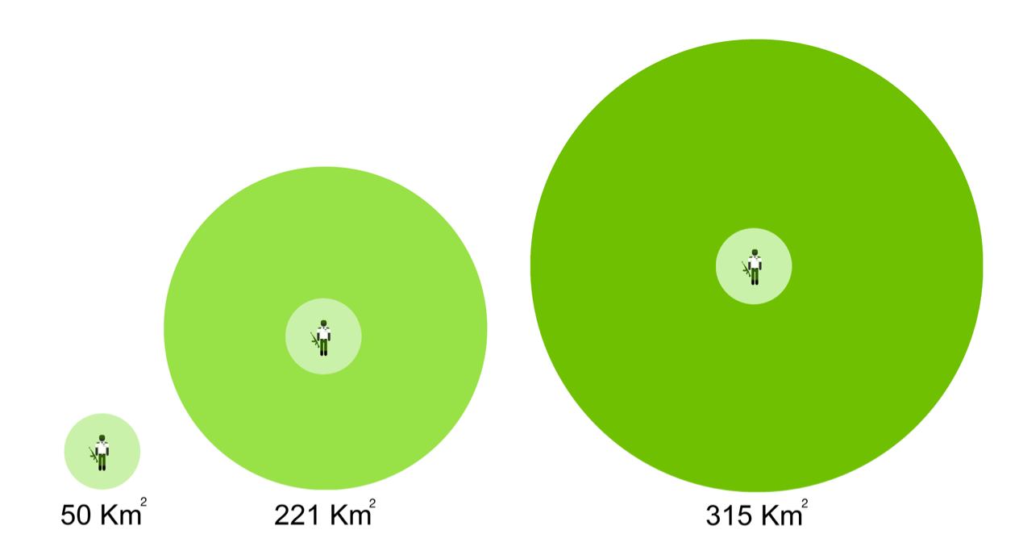
Figure 22. Density of law enforcement force of the Parks and Reserves in Mozambique, comparing the number of available and capable scouts to the recommended number (1 officer per 50 Km²).
Apart from the scouts of the Ministry of Tourism that operate in the Parks and Reserves, the Government has, in the Districts and Provinces, a law enforcement force of about 700 scouts of the District Services for Economic Activities (SDAE). Although these scouts assist in the poaching processes, they are more involved in matters concerning forest exploitation and the Human-Wildlife Conflict, and they don't perform patrolling activities.
Scout Management
The presence of scouts in the area is important, but it is even more vital that there be an effective management process in place. This process should ensure that the law enforcement team is efficient, with trained scouts, and monitoring the patrols that are carried out. They should constantly report to a competent structure and should be able to adapt to and innovate new law enforcement strategies as needed.
It is, therefore, important to have a database that registers the efforts and results of the law enforcement team. Unfortunately, centrally, there is no database, although some areas have their own system. The way in which areas register the activities vary from area to area; they record it differently. Some record the "patrol days" (total number of days the team spent on patrols), others record "number of patrols" while others, "patrols per day/scout" (cumulative value of the number of days each member of the team has on patrol). The level of effort is sometimes best reflected in the heading "patrol days", as it takes into account the effect that the size of the patrol team has on the effective number of patrol days; and it is a more effective way of comparing efforts between areas that use patrol teams of different sizes.
The management of the law enforcement team should be an exemplary principle, with effective disciplinary processes, and individuals should take responsibility or be expelled if necessary. However, some of the Conservation Area managers point out the length of time processes take to be handled. Very often staff are simply transferred to other areas, when probably they deserved to be dealt in a more serious way. The processes to dismiss and recruit scouts are equally lengthy, and are known as one of the constraints which some of the conservation areas face (for example, the Limpopo National Park)³⁵.
Equipment and Infrastructure
The type of equipment and infrastructures available to the law enforcement team varies from area to area, and depends on, among other things, how they were (or are) managed and the access to alternative funds. Some areas were able to invest in building their accomodation blocks for their law enforcement team, while others only have tents. The quality and quantity of equipment also varies extensively from area to area; some areas having more than 20 operational vehicles which are dedicated to conservation and enforcement activities (example, Gorongosa National Park), while others only have 2 working cars (example, Gilé National Reserve). On the whole, most of the interviewees reported that both the equipment and the infrastructures in the Conservation Areas are not adequate to deal with their current and future needs. The provision of suitable conditions, as well as the existence of an efficient management system, may influence the motivation levels of the scouts. According to some interviewees, motivation is one of the most important factors in achieving successful results for the law enforcement team.
There is also an inadequate use of sophisticated technologies to assist in the poaching activities. This means that, most of the successful operations depend mostly upon the human resource capacity; whereas with the application and use of technologies, the number of scouts needed may reduce; which helps to minimize the necessary costs as well as the risk of conflicts between the scouts and the poachers. For example, the use of thermal imaging, unmanned airplanes, satellite images. This year, Kenya, for example, in an effort to improve the monitoring and detection of Elephant and Rhinoceros poaching, decided to employ unmanned airplanes in all of its 52 Parks and National Reserves⁹⁸.

The Budget
One of the crucial factors that influences the ability to provide the necessary conditions for the Parks and Reserves to have a more effective and efficient law enforcement team, is the amount of investment that is given to them by either General Government Budget (OGE), or by other partners. Jachmann (1998) calculated an estimate for Zambia of roughly USD 80 per km² per year was needed for a capable law enforcement team⁹⁹. This figure includes salary expenses, land dislocation, vehicles, equipment and other necessary staff accommodation. For the Parks and Reserves in Mozambique, an investment of about 6.5 million dollars per annum would be necessary. The annual funds available for the management of the Parks and Reserves is, however, significantly lower. For example, for 2014, of the 10.8 million American ollars that MITUR is estimated to receive from OGE (equal to 0.13 % of OGE), about 1 million dollars are used to cover expenses of the Parks and Reserves (representing 10% from the Ministry, and 0.01% from OGE). This relates to about only 15% of the amount considered necessary. Even taking into account that some areas manage to generate some income, and receive contributions of partners such as Fondation Internationale pour la Gestion de la Faune (IGF), WCS and the Peace Parks Foundation (PPF) that assist in paying staff salaries (and other management expenses) for the Gilé National Reserve, Niassa National Reserve and the Maputo National Reserve respectively, the available amounts are still very much below the amounts needed.
Another factor that was raised by the interviewees is related to the easiness of access to funds, especially the revenue raised by certain Parks and Reserves, and that should be returned to the respective areas. There are still difficulties in some areas accessing these funds, for example, Limpopo National Park. This causes some serious inhibitions in the management and operation of the Park, for example, the ability to acquire food and fuel needed to conduct patrol operations.
In general, the interviewees considered as urgent the necessity to revise the budget threshold which the General State Budget provides to the Conservation Areas, thereby allowing a greater investment in enforcement teams. Greater collaboration with the NGO's and the Private Sector, strengthening its involvement in matters relating to the Conservation Areas, including through attractive management methods, can also bring additional assistance with regard to human, technical and financial resources.
The Private Sector
The private sector's work on law enforcement is often not highly referred to. This sector, however, plays a significant role in law enforcement of the areas that are concessioned to them. The private sector invests in the necessary resources and is operational on a ground level, and this encourages fewer illegal activities. For example, with the new Operator enforcement team of the L5S Management Unit in the Niassa National Reserve, there has not only been a reduction in the levels of elephant poaching (about 25 elephants hunted per annually in 2010 and 2011; while about 15 in 2013), but also a change in the affected areas (from the region around the Mbamba village to the areas further East of the L5S)¹⁰⁰.
It is estimated that there are at least 371 scouts in operation in the 'Coutadas' area. If we add the number of scouts in the Game Farm area (figures not available) to this number, we can understand the contribution that the private sector plays in the protection of wildlife resources in the country. However, this sector has complained about the support that is provided by the State, including serious difficulties in the swearing in process of their scouts in the District Courts.

Area |  | Area (Km²) | No. of Scouts | Scout/  Km²
 | Operator
Coutada Nicage | Kambako | NA | NA | NA
L9 - RNN | East Africa Safari | 2,910 | 0 | 0
L7 - RNN | Luwire | 4,446 | 61 | 73
R3 - RNN | Mazeze | 2,671 | 6 | 445
L8 - RNN | Kambako | 2,125 | 7 | 304
L5N - RNN | Miuro | 1,828 | 12 | 152
L6&R6 - RNN | Chuilexi | 4,626 | 4 | 1,157
R1 - RNN | Lucheringo | 3,458 | 55 | 63
Coutada Nacumua | TraditionalMozambique Safaris | 2,714 | 2 | 1,357
Coutada Nipepe | Mabarule Hunters Mozambique | 1,383 | 5 | 277
L2 - RNN | Johan Calitz Safaris | 4,180 | 22 | 190
L5S - RNN | Mariri | L5N | 14 | NA
Coutada 11 | Promotur | 1,928 | 17 | 113
Coutada 10 | Marromeu Safaris | 2,008 | 19 | 106
Coutada 14 | Nyati Safaris | 1,353 | 25 | 54
Coutada 13 | Stimbak Safaris | 5,683 | 50 | 114
Coutada 12 | NyalaSafaris(Grupo Entreposto) | 2,963 | 21 | 141
Coutada 5 | Africa Futura Wildlife Restoration | 6,868 | NA | NA
Coutada 7 | Vinson G&G | 5,408 | NA | NA
Coutada 4 | Reserva Búfalo Limitada | 4,300 | 0 | 0
Coutada 9 | Rio Save Safaris | 4,333 | 51 | 85
 |  | 65,185 | 371 | 165
Training
The law enforcement team's level of training is, in general, low. In addition, not all the conservation areas offer specific law enforcement training at the required level and quality. Mozambique had a Training School for scouts, situated in the Gorongosa National Park, which was managed in partnership with the WWF, but it is no longer operational. The training courses are now held on an ad hoc basis for each conservation area, but don't follow a standard training curriculum.
In 2011, The Niassa National Reserve, situated in the far North of Mozambique, started a recruitment and training programme. It relied on the experience and knowledge of an Tanzanian-based organization (Conservation Outcomes) which is specialized in the area of scout training. This programme is still operational, and has improved the methods and processes for pre-selection, selection, basic training, advanced tactical training and refresher training. This programme has not only strengthened the quality of law enforcement scout training, but it has also influenced the recruitment process; taking on motivated people and people with the necessary qualities either to be Reserve scouts or scouts of the private operators within the Reserve. The Limpopo National Park, in the south of the country, in turn, formed a partnership with the Southern African Wildlife College (a South African College), to train its law enforcement scouts.
In both cases, besides the specific abilities and the knowledge of anti-poaching that the scouts learn, the training includes a component in the use and carrying of firearms which, in general, is carried out in partnership with the Mozambique Republic Police. The interviewees, nonetheless, raise the fact that there should be specific training in certain areas, as, for example, in the area of investigation and intelligence (currently there are no scouts trained in these areas). Having persons trained in intelligence could help in identifying and analyzing the type and location of poaching activities, hereby reinforcing the efficiency of the interventions. This lack of proper intelligence work restricts the ability to foresee criminal activities, encouraging a reactive instead of a preventative attitude within the enforcement teams.
The level of officer training in the private sector is also very low, having in many cases, operators that don't have any officer who has had specific training.
The Customs
The Customs deal with customs services which record the import and export of merchandise, and monitor and effect entry and exit rights of these. They, therefore, play a crucial role in the control of the country's ports and airports, detecting, among other things, the transit of illegal products.
The Customs offices have already carried out some operations to detect illegal transiting of ivory and rhinoceros horns, and have already made some arrests at the Maputo Airport, Beira and Pemba, as well as the ports of Maputo, Nacula and Pemba. However, the available technology is not yet adequate to detect products such as ivory and rhinoceros horns. This results in having to rely on denunciation and on the abilities of the existing human resources.
The training of custom officials with regard to poaching and illegal trade is still very limited, and this reduces the ability and sensitivity to act on the matter¹⁰¹. Many of the customs officials are aware that it is necessary to have documents from the Agricultural Ministry to export species out the country, but not all of them know about the CITES certificate; much less on how to identify the species listed in the various appendixes¹⁰². The customs offices have already held some training courses on matters related to CITES, and the identification of flora and fauna products, but the course only benefited a very small number of officers (about 70)¹⁰².
The way in which the products have been exported has made it difficult to identify them. Rhinoceros horns are cut in pieces (see figure below) and the ivory horns are ground into powder¹⁰². This raises the need to invest in other forms of detection that go beyond human capacities (ie. use of sniffer dogs). At the end of 2013, TRAFFIC, together with the DNTF and the Customs Offices, carried out a pilot exercise with sniffer dogs at the Maputo International Airport, in order to detect products such as ivory. The exercise lasted a week and did not lead to any apprehension. It is believed that this is more due to a leak in information (i.e. one knew when this exercise was happening and for how long) than the method itself¹⁰¹. The various interviewees considered this to be a good technique and agreed that this should continue to be implemented using a more efficient strategy.
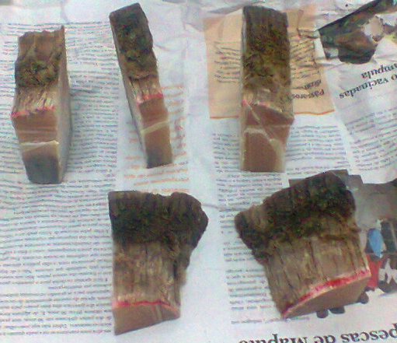
Figure 23. Rhinoceros horn cut in pieces, that were apprehended on 2 June 2013, Maputo International Airport (source: Mozambican Tax Authority).

CITES
CITES (Convention in International Trade in Endangered Species of Wild Fauna and Flora) is an international agreement between Governments, with the objective to control the international trade of fauna and flora species in to order to avoid them becoming extinct.
In 1981, Mozambique ratified the CITES Convention, having established the Administrative Authority as well as the Scientific Authority for its management. The Administrative Authority was under MINAG management until 2008, but then changed its management to MICOA (even though, until date, MICOA needs to rely on MINAG support). In 2008, the Eduardo Mondlane University in Mozambique, assumed responsibility as a Scientific Authority, having among other responsibilities, issuing of advise for those included in Annexures I and II of CITES, that attest to the fact that exploitation is not detrimental to the survival of the natural species. Although this kind of opinion is crucial when the Administrative Authority needs to make an informed decision with regard to the issuing of Licences, these two Authorities have not yet developed an affective partnership programme.
The Administrative Authority still has shortcomings, ranging from the existence of the required legislation, to human resources that are trained and have the necessary motivation, equipment and facilities. This inadequate investment in the functioning of this Authority has affected the performance of its responsibilities. In 2012, quotas on leopards failed to be published due to the Administrative Authority's lack of management. The same thing happened again in 2013 with respect to the crocodile, elephant and lion quotas. Further to this, due to the Administrative Authority's failure to comply with some necessary steps (e.g. the submission of reports to CITES, the ban on Hippo export happened in 2013. These situations have caused serious disruptions in country's hunting industry.
In addition, the Administrative Authority drafted a new CITES Regulation (approved by the Government on 26th April 2013, through Decree 16/2013), which contains errors, introduces impractical procedures and drastically increases the fee for issuing the CITES export certificate by 2.300%. Even more detrimental was the fact that this document was produced without the required involvement of the private sector, especially the part of civil society most affected by this regulation - i.e. those involved in sport hunting¹⁰³.
Furthermore, as a result of the concerning involvement of Mozambique in the illegal trade of species, and the way in which poaching was addressed (in terms of its legislation and response within its field), CITES submitted a few resolutions for Mozambique to comply with (e.g. Resolution 16.87 and Resolution 9.14, especially aimed at the Rhinoceros). The delay in responses to these issues, has raised an intense debate as to whether Mozambique will suffer sanctions by CITES¹⁰⁴.
As a result of Mozambique not complying to a number of reports required by CITES, the Environmental Investigation Agency and the International Rhinoceros Foundation, submitted a petition to the United States Government requesting a ban on trade with Mozambique on all species listed in CITES and the consideration of other appropriate commercial sanctions. Further to presenting a list of disregards by Mozambique to CITES requests, the petition tries to show that Mozambican nationals are lowering the effectiveness of CITES, by their inability to control poaching and the illegal trade of ivory and Rhinoceros horns¹⁰⁵.
Mozambique recently approved a new legislation for the Conservation Areas which introduces poaching as a criminal activity (with some fines that reach up to between 8 and 12 years imprisonment term), ratified a Memorandum of Understanding with South Africa (referred to in chapter III), submitted a report to CITES on the Rhinoceros, and is working to update CITES legislation. These actions need to be considered at the next CITES meeting, as well as by the United States Government, although it is not yet known as to whether they are enough to avoid sanctions being imposed on Mozambique.

Awareness and Benefits
The interviewees identified this area as being one of the most relevant areas - the need to intervene in the awareness of civil society as a whole, especially at the highest political and governmental levels. This includes awareness campaigns that are not only aiming in trying to show the ecological and biological concerns with regard to the loss of these species, but are also mainly concerned with national security matters (the presence of illegally armed national and foreign groups), establishing an organized criminal network, and on the negative impacts on the international image and reputation of the country, and in its economic development, especially on tourism. It is recognised, however, that this is still one of the areas that have weaker interventions.
Recently, Mozambique’s Attorney General, during his annual report to Parliament, included a statement about poaching and the new Conservation Areas Law, referring to the need to criminalize such acts. The Minister of Tourism has also spoken about this in some of his interviews. However, the level of attention that this matter has received from senior leaders has been far below what most interviewees consider to be important.
On a local level, most of the Conservation Areas have done little work on raising awareness and communication on the values of conservation with the local communities. With the exception of some Parks and Reserves (e.g. Maputo National Reserve, Gorongosa National Park), the majority do not have a structured programme and the necessary human resources and finances to effectively address this matter. Some rely on partnerships with other provincial government sectors and NGO's. For example, in the Quirimbas National Park, the Provincial Directorate for Environmental Coordination conducts environmental educational campaigns within the communities, where various issues are addressed (e.g. fires, indiscriminate killing of species, etc). There is, however, no follow up with regard to investigating of results or ascertaining the effectiveness or advantage of these awareness campaigns.
Some of the interviewees believe it is still necessary to undergo a lengthy and arduous process of education, capacity building and awareness, and to create effective community structures and groups. The interventions could aim to show the benefits of living with dangerous species such as the Elephant - a species that is currently seen as being more costly than beneficial (i.e. placing its life and food security at risk). At this point, most of the interviewees point out that the main benefit would be the sharing of the 20% revenue. However, besides the major operational problems and the management of the 20% revenue, most of the interviewees also believe that there is no perception by the communities about the link between these benefits and the Conservation Areas. It would be important to monitor and evaluate the impact of this 20% revenue on reducing poverty and the link with biodiversity conservation.
Some of the Safari Operators indicated their contribution in terms of corporate social responsibility, providing meat, equipment (e.g. maize mills) and infrastructures (e.g. schools and water wells), a certainly important contribution, and one that adds to employment that is generated by this private sector. There is still a need, however, to establish good initiatives where the communities are effectively involved in management, not only benefiting from a percentage of the revenue, but also sharing in the responsibilities of resource management. The new Law of Conservation Areas introduces some categories of Conservation Areas that allow the regulation of such initiatives, leaving only the initiatives that make use of this legislation by translating them into actions on ground level.

Recommendations

The interventions that are currently implemented are not effective; the trends in poaching and illegal trade are escalating exponentially. It is therefore extremely important to adopt new strategies to reverse the situation.
In 2012, the International Consortium for Combating Wildlife Crime (ICCWC) launched a new edition of its Analytical Tools on how to deal with crimes related to Wildlife and Forests¹⁰⁶. This Consortium consists of organizations such as United Nations Office for Drugs and Crime (UNOCD), the Secretariat of CITES, the International Criminal Police Organization (INTERPOL), the World Bank and the World Customs Organization (WCO). The Analytical Tool was designed to help government officials with the responsibilities in the administration of the areas of wildlife flora and fauna, customs and other legal offices. The Analytical Tool allows for the comprehensive evaluation of the methods and ways or protecting wildlife flora and fauna and by monitoring its use it can identify the technical assistance needed. The implementation of this Tool may help in identifying the intervention areas.
As was mentioned in the previous sections, the fight against illegal trade and the poaching of elephant and rhinoceros, involves a diversity of stakeholders. Sometimes, each of the stakeholders sees his/her situation differently in terms of trends, causes and necessary solutions needed. In the various meetings held during this study it was possible to establish this fact, with some organizations more inclined to provide armed response on ground level, while others focused more on the environmental education of civil society and the Government. There is, however, a shared perception that, given the complexity of the poaching and illegal trade issue, the interventions that are to be carried out should pay attention to addressing the different sections involved.
The various recommendations made by the interviewees during this study, as well as those referred to in previous reports, were grouped into three principal types of interventions :
1 - Interventions in Law Enforcement - interventions that aim to reinforce the capacities of law enforcement on the whole - from the legal component, to the detection to seizing of goods on land, at the ports and airports. The following actions were suggested:
a. To reinforce the capabilities of the Conservation Areas law enforcement force;
b. To improve the Management System of the Conservation Areas law enforcement force;
c. To strengthen the intervention capabilities of the Private Sector's law enforcement orce;
d. The introduction of a Special Police Law Enforcement Force for matters on the protection of natural resources;
e. To reinforce law enforcement at ports and airports in order to detect the illegal transit of rhinoceros horns and ivory;
f. To improve the Legislation;
g. To improve the Judiciary System.
2 - Interventions in Awareness - interventions that aims to reinforce the knowledge and sensitivization of matters relating to the fauna species, especially the elephant and the rhinoceros, on all levels - from the most powerful politician to other sectors of civil society. The following actions were suggested:
a. Sensitivization at high Government and Political levels;
b. Sensitivization in the Provincial Capitals and Districts.

3 - Interventions in Community-based Initiatives - interventions that vision reducing the costs and increasing the benefits of co-inhabiting with dangerous species such as the elephant. The following actions were suggested:
a. To reduce the Human-Elephant Conflict;
b. To introduce initiatives and mechanisms for the community wildlife management.

These recommendations were presented and discussed at a workshop that was held in Maputo on the 18th and 19th June 2014. Over 60 people attended this workshop, including many of the parties interviewed during this study, various government sectors, NGO's, donors, academics and private sector members. From the list of grouped recommendations, the interviewees identified the following three principals as needing prioritized attention. (The full list of recommendations made by the various interviewees is included is Annexure 3).

Improve the Interventions in Law Enforcement
a. Reinforce the capabilities of the law enforcement force in the Conservation Areas
i. The capacity of the current law enforcement force is not adequate enough to deal with the types of threats that poaching has created in various conservation areas in the country. It is recommended that scout numbers be increased in the Parks and National Reserves, especially in the areas in which there have been the majority poaching incidences.
ii. To urgently establish intensive law enforcement operations that are in collaboration with the key sectors, and possibly with national and international organizations (for example, LATF, INTERPOL, TRAFFIC); in the more critical Conservation areas (for example, Niassa National Reserve, Quirimbas National Park, Limpopo National Park and the Mágoè District).
iii. To evaluate the need and relevance of establishing specific Plans and specific Task Groups for each critical area, in order to better drive, supervise, coordinate and support the ideas to be implemented. The specific Plans should include a current analyses of the actual causes, the way in which the poaching is carried out, the principal entities involved and the networks that are established.
iv. To conduct an evaluation on the training levels of the scouts in all the Conservation areas, i.e. including the' Coutadas'. This evaluation may be conducted in collaboration with INTERPOL trainers and other regional organizations that offer specialised training for scouts ; thereby designing an effective programme adapted for the country. The training needs to include specific components such as leadership, knowledge and information analyses.
v. To evaluate the possibility of improving the incentives of the law enforcement task force by, amongst other things, introducing a bonus system which is based on results, annual performance awards such as for "Scout of the Year."
vi. To urgently investigate the connections between the transnational criminal networks, the poachers, the scout force, traders and consumers in Mozambique.
vii. To conduct a thorough investigation on the source of weapons that are involved in poaching, especially the sophisticated weapons.
viii. To strenghten the available equipment in order to carry out effective patrols (which includes access to airplanes and helicopters when necessary).
ix. To introduce modern equipment and technology for the detection and apprehension of poaching and illegal trafficking cases (for example, the use of thermal cameras, night vision binoculars, unmanned planes, images, etc).

To improve Awareness on the poaching matter
It is an individual's choice to hunt, but he/she may be influenced by society, politics or the economy in which he/she lives. In order to successfully implement interventions to change people's attitude and behaviour, it is necessary to understand the factors that lead the individual making certain decisions. This requires a comprehensive sensitivization approach about awareness on various levels and sectors. The message needs to be unanimous, thereby emphasizing the seriousness of the situation.

a. Awareness at a high Governmnent and Political level

i. It is of utmost importance that government institutions, powerful political figures, including the President of the Republic, make public announcements on how poaching has negative impacts on the country's international image and reputation, on economic growth, especially tourism, and on national security by presence of illegally armed national and foreign groups, and in the establishment of organized crime networks, as well as the relevant ecological and biological impacts.
ii. This being a general election year the opportunity should be taken to influence the Government's future legislation review process to include consolidation of functions and an improved budget. The Government needs to allocate a higher budget to the Conservation Areas in order to reinforce their capabilities and performance.
iii. Organise a national seminar and invite leading companies, businesses and public figures of Mozambique who support anti- poaching activities and the illegal trade of elephant and rhinoceros.
iv. Promote a dialogue for strengthening cooperation in fighting these kind of cases with countries, particularly China and Vietnam through their Embassies. This may include Awareness and Educational Campaigns, especially related to the new penalties introduced in the new Law of Conservation Areas.
v. In 2013 the Eduardo Mondlane University assessed the logging situation in Mozambique and calculated a State loss of about 11.60 billion dollars for 2011 alone due to the non-payment of logging charges (i.e. illegal exploitation). A similar study should be done to assess the fauna situation, revealing its contribution to the national economy and the impact of poaching and illegal trade.

To improve Community-based Interventions
Some of the interviewees raised their concern with regard to the focus on interventions using heavy military tactics, as these could be counter-productive and alienate communities in the long run (this opinion was also shared in some of the global studies on the topic¹⁰⁷). This is a significant concern for a country which has a population of over 200 thousand inhabitants living in the Conservation Areas. It is necessary to review the involvement process with the local communities that live with the wildlife, ensuring that the benefits of living with these species outweigh the costs.
However, recent studies also show that an improvement in conditions and generating revenue for the communities involved in poaching does not necessarily mean a reduction in poaching activities¹⁰⁸. Evidence from the studies indicates that many times, economic alternatives result in constituting additions and not replacements. That is, while communities benefit from the new measures, they also continue to make use of illegal smuggling of resources. It is therefore necessary to monitor with the necessary attention the cases that are implemented.

a. Introduction of community management initiatives and mechanisms for fauna
i. Explore the opportunities that the new Law of Conservation Areas introduces with regard to establishing conservation initiatives within the community.
ii. Review the legal process in order to facilitate the establishment of game farms that involve the local community, with the objective of supplying the local market with hunting meat.
iii. Evaluate the possibility of the communities commercializing their community quota (including that of elephant) to sport hunting operations; providing a great and direct benefit of coexisting with such a species.

References

1 - CITES. (2014). SC65 Doc. 42.1. Sixty-fifth meeting of the Standing Comittee Geneva (Switzerland), 7-11 July 2014. Interpretation and implementation of the Convention, Species trade and conservation, Elephants. Elephant Conservation, Illegal Killing and Ivory Trade.
2 – CITES. (2013). COP16 Doc. 54.2. Sixteenth meeting of the Conference of the Parties Bangkok (Thailand), 3-14 March 2013. Interpretation and implementation of the Convention, Species trade and conservation, Rhinoceros – Report of the Secretariat.
3 – Myburgh, J. In: Haken, J. (2011). Transnational Crime in the Developing World. Global Financial Integrity. Washington, DC. USA. In: WWF/Dalberg. (2012). Fighting illicit wildlife trafficking: A consultation with governments. WWF International. Gland. Switzerland.
4 – Global Financial Integrity. (2011). Transnational Crime in the Developing World. Disponível em: http://transcrime.gfintegrity.org/.
5 – www.olpejetaconservancy.org/wildlife_conservation/northern-white-rhinoceros
6 – Balmford, A. (2012). Wild Hope – On the Front Lines of Conservation Success. The University of Chicago Press. London.
7 – www.rhinoceros.org/rhinoceros/state-of-the-rhinoceros-2013.
8 – library.sandiegozoo.org/factsheets/black_rhinoceros/black_rhinoceros.htm.
9 –Tello, J.L.P.L. (1977). Situação de Algumas Espécies Mamalógicas. (Situation of some "mamalogica" species). Boletim DINAP Moçambique no. 1 (1974/1976). pp 93-118. Maputo, Mozambique.
10 – Tello, JLL & Dutton, P.T. (1979). Ecological Recognition of the Rovuma/Lugenda region, in light of the creation of a National/ International Park. Ministry of Agriculture. Maputo, Mozambique.
11 – Emslie, R. & Brooks, M. (1999). African Rhinoceros - Status survey and conservation action plan. IUCN/SSC African Rhinoceros Specialist Group. IUCN, Gland, Switzerland & Cambridge, UK.
12 – Smithers, R. & Tello, J.L.P.L. (1976). Checklist and Atlas of the Mammals of Mozambique. Museum Memoir no. 8, Rhodesia The Trustees of the national museum and Monuments of Rhodesia, Salisbury.
13 – Jorge, R.M.P. (2010). Estudo do impacto dos factores antropogénicos sobre a distribuição dos rinocerontes Ceratotherium simum (Burchell, 1817) e Diceros bicornis (Linnaeus, 1758) nos periodos de 1963 à 1979 e de 2002 à 2009 em Moçambique. (The study of the impact of the anthropogenic factors of the distribution of the Ceratotherium simum Rhinoceros). Trabalho de Culminação de Curso. Universidade Eduardo Mondlane. Maputo, Moçambique.
14 – Tello, J.L.P.L. (1977). Situação de Algumas Espécies Mamalógicas. Boletim DINAP Moçambique no. 1 (1974/1976). pp 93-118. Maputo, Moçambique.
15 – TRAFFIC. (2013). Rhinoceros FAct Sheet – Illegal Wildlife Trade Campaign.
16 – Milliken, T. & Shaw, J. (2012). The South Africa – Viet Nam Rhinoceros Horn Trade Nexus: A deadly combination of institutional lapses, corrupt wildlife industry professionals and Asian crime syndicates. TRAFFIC, Johannesburg, South Africa.
17 – Save the Rhinoceros, available on : www.savetherhinoceros.org/rhinoceros_info/threats_to_rhinoceros/poaching_for_traditional_chinese_medicine.
18 – The Independent, available on : www.independent.co.uk/voices/comment/ferrari-factor-how-vietnams-wealthy-elite-have-made-rhinoceros-horn-worth-its-weight-in-gold-9080021.html.
19 - Milliken, T., Emslie, R.H., e Talukdar, B. (2009). African and Asian Rhinoceros – Status, Conservation and Trade: A report from the IUCN Species Survival Commission (IUCN/SSC) African and Asian Rhinoceros Specialist Groups and TRAFFIC to the CITES Secretariat pursuant to Resolution Conf. 9.14 (Rev. CoP14) and Decision 14.89. Doc. CoP15 45.1 Annex, CITES Secretariat, Geneva, Switzerland, pp. 19.
20 – www.environment.gov.za/mediarelease/rhinocerospoaching_statistics_17jan2014.
21 –www.sanparks.org.
22 –www.cybertracker.org/downloads/environment/PosIT-CyberTracker-March13.pdf
23 –www.dod.mil.za/operations/poaching/rhinoceros.htm.
24 – Vira, V. & Ewing, T. (2014). Ivory’s curse – The Militarization & Professionalization of Poaching in Africa. BornFree USA and C4ADS.
25–www.iol.co.za/scitech/science/environment/army-to-join-kzn-rhinoceros-effort-1.1586327#.U221pFy3ods.
26 – Billy Swanepoel, comunicação pessoal.
27 – Save the Rhinoceros. (2014). Mozambique’s Role in the Rhinoceros Poaching Crisis. Save the Rhinoceros, 2013 Disponível em: www.savetherhinoceros.org/rhinoceros_info/thorny_issues/mozambiques_role_in_the_poaching_crisis.
28 – Michler, I. (2012). The Mozambique connection to rhinoceros poaching. Africa Geographic, Disponível em: http://showme.co.za/lifestyle/the-mozambique-connection/.
29 – Ellery Worth, comunicação pessoal.
30 – World Health Organization. (2014). Mozambique: Statistics. World Health Organization, Available on em http://www.who.int/countries/moz/en/.
31 – Data from the Limpopo National Park.
32 –macua.blogs.com/moambique_para_todos/2013/07/detidos-agentes-da-prm-envolvidos-na-caça-do-rinoceronte-no-distrito-de-magude.html.
33 – macua.blogs.com/moambique_para_todos/2013/09/caçadores-furtivos-detidos-em-investida-no-kruger-park.html#more.
34 - macua.blogs.com/moambique_para_todos/2014/01/detido-comandante-da-prm-em-massingir-por-envolvimento-em-caça-furtiva-de-rinocerontes.html.
35 - Antony Alexander e Billy Swanepoel, personal communication.
36 – Data from the National Directorate of Land and Forests.
37 - www.google.com/hostednews/afp/article/ALeqM5h6tZ7uQaf36f1SafM4fwTwYl5sgw?docId=CNG.6c948443674a73ed3c7ca864fc21eea1.4c1.
38 - www.bernama.com/bernama/v6/newsindex.php?id=671093.
39 - annamiticus.com/2012/09/07/rhinoceros-horn-shipment-from-mozambique-seized-in-philippines/.
40 - vietnambreakingnews.com/2013/01/tan-son-nhat-airport-police-seize-16-5-kg-of-rhinoceros-horns/#.UhWjWNKnrGA.
41 - allafrica.com/stories/201302210175.html.
42 -envietnam.org/E_News/Daily_News/Vietnamese_with_rhinoceros_horns_seized_at_Africa_airport.html.
43 - www.straitstimes.com/breaking-news/se-asia/story/rhinoceros-horns-worth-s730000-seized-bangkok-airport-20130107.
44 - www.standardmedia.co.ke/?articleID=2000093749&story_title=vietnamese-man-arrested-with-five-pieces-of-rhinoceros-horns.
45 - news.asiaone.com/news/crime/vietnamese-jailed-15-months-smuggling-rhinoceros-horns-worth-more-1-million &
46 – Sebogo, McLellan & Stephenson. (2013). WWF Species Action Plan: African Elephant, 2012-2015. WWF International. Gland, Switzerland.
47 – www.elephantdatabase.org.
48 –UNEP, CITES, IUCN, TRAFFIC. (2013). Elephants in the Dust – The African Elephant Crisis. A Rapid Response Assessment. United Nations Environment Programme, GRID-Arendal.
49 – Maisels, F., Strindberg, S., Blake, S., et al. (2013) Devastating Decline of Forest Elephants in Central Africa. PLoS ONE 8(3).
50 – CITES, IUCN, TRAFFIC. (2013). Status of African Elephant populations and levels of ilegal killing and the ilegal trade in ivory: A report to the African Elephant Summit.

51 – www.elephantdatabase.org/preview_report/2013_africa/Loxodonta_africana/2012/Africa/Southern_Africa/Botswana.
52 – Blanc, J. (2008). Loxodonta africana. Em: IUCN 2013. IUCN Red List of Threatened Species. Version 2013.2. <www.iucnredlist.org>.
53 – IUCN. (2012). IUCN Red List Categories and Criteria: Version 3.1. Second edition. Gland, Switzerland and Cambridge, UK: IUCN. iv + 32pp.
54 – Agreco. (2008). National Census of Wildlife in Mozambique. Ministry of Agriculture. Maputo, Mozambique.
55 – MITUR. (2010). Strategy and Action Plan for the Conservation and Management of Elephants in Mozambique, 2010 – 2015. Ministry of Tourism. Maputo, Mozambique.
56 – Dunham, K.M. (2012). Trends in populations of elephant and other large herbivores in Gonarezhou National Park, Zimbabwe, as revealed by sample aerial surveys. African Journal of Ecology, 50(4), pp. 476-488.
57 – Agreco. (2010). Wildlife Survey Phase 2 and Management of Human-Wildlife Conflicts in Mozambique. Part 4 – Aerial Survey of Wildlife south of Lake Cahora Bassa. Ministry of Agriculture. Maputo, Moçambique.
58 – Graham Cawood e Richard Fergusson, comunicação pessoal.
59 - pamsfoundation.org/our-initiatives/ruvuma-elephant-project/
60 - CITES (2012). COP16 Doc. 53.1. Sixteenth meeting of the Conference of the Parties Bangkok (Thailand), 3-14 March 2013. Interpretation and implementation of the Convention, Species trade and conservation, Elephants. Monitoring the Illegal Killing of Elephants. Including Cop16 Doc. 53.1 Addendum.
61 – Sociedade para a Gestão e Desenvolvimento da Reserva do Niassa. (2010). Relatório sobre Caça Furtiva e outras actividades ilegais. Departamento de Conservação e Fiscalização. Mbatamila, Moçambique. (Society for the Management and Developmnet of the Niassa Reserve. (2010). Report on poaching and other illegal activities. Department of Conservation and Law enforcement. Mbatamila, Mozambique).
62 – Craig, G.C. (2009). Aerial Survey of Wildlife in Niassa Reserve and Adjacent Areas, 2009. Sociedade para a Gestão e Desenvolvimento da Reserva do Niassa. Moçambique.
63 - Craig, G.C. (2012). Aerial Survey of Wildlife in the Niassa Game Reserve, 2011. Society for the Management and Development of the Niassa Reserve. Mozambique.
64 – Carlos Lopes Pereira e Cornélio Miguel, personal communication..
65 - Valoi, E. (2014). O drama de caça furtiva ao elefante em Moçambique. (The drama of elephant poaching in Mozambique. eyewitness. 30 Jan. 2014. Blog. available on: <http://valoie.blogspot.com/2014/01/o-drama-da-caca-furtiva-ao-elefante-em.html>.
66 – Society for the Management and Development of the Niassa Reserve (2012). Information Bulletin, nº 13. Mozambique.
67 – Niassa Reserve. (2013). Annual report 2013. MITUR.
68 – Craig, G.C. (2013). Aerial Survey of Quirimbas National Park and Adjoining Areas, 2013. WWF Mozambique Country Office. Moçambique.
69 - Craig, G.C. (2012). Aerial Survey of Quirimbas National Park and Adjoining Areas, 2011. WWF Mozambique Country Office. Mozambique
70 – Jacob Landsberg, personal communication.
71 - www.verdade.co.mz/nacional/16770-na-carga-apreendida-encontradas-126-pontas-de-marfim
72 – Interpol. (2012). Disponível em: http://www.interpol.int/News-and-media/News/2012/PR049.
73 – Ministry of Tourism. (2012). Poaching in Moz – A Threat to the Forest and Wildlife Resources. Maputo, Mozambique.
74 - earthenginepartners.appspot.com/science-2013-global-forest
75 - lusakaagreement.org
76 - Mozambique Revenue Autthority. (2014). Communication in the International Press of Operation Cobra II - 12 February 2014. International team of law enforcement officers in arresting wildlife offenders. Maputo, Mozambique
77 – Interpol. (2014). Elephant Poaching and Ivory Trafficking in East Africa: Assessment for an Effective Law Enforcement Response. General Secretariat. Lyon, France.
78 – Mozambique Government. (2014). National Programme for the Protection of Natural Resources and the Environment. Power Point Presentation. Maputo. Mozambique.
79 – Ministry of Tourism. (2010). Strategy and Action Plan for the Conservation and Management of Elephants in Mozambique. Maputo, Mozambique.
80 - Ref. Articles 134 e 212, n.° 2, of the 2004 Constitution.
81 - The right to class action is embodied in Article 81 of the 2004 Constitution.
82 - Ref. Article 236 of the 2004 Constitution.
83 – Ref. Article 4 of the Organic Law of Public Ministry (2007).
84 – Ref. Article 2 of Law 16/2013, of 12 August, Law of the Republic of Mozambique Police.
85 – Ref. Article 13 of the Law of the Republic of Mozambique Police.
86 – Ref.. Article 14, n.° 1, i) of the Law of the Republic of Mozambique Police.
87 – Ref. 15 of the Law of the Republic of Mozambique Police.
88 – According to Article 17 of the Law of the Republic of Mozambique Police , " during the preparatory instructions of the criminal charges, the Criminal Investigation Police acts under the direction of the Public Prosecutor, without any prejudice to the respective hierachical organization”.
89 – Ref. 18 of the Law of the Republic of Mozambique Police
90 – Ref. 23 of the Law of the Republic of Mozambique Police
91 – Ref. 24 of the Law of the Republic of Mozambique Police
92 – Ref. 13 of tthe Law of the Republic of Mozambique Police
93 - Veja-se Artigo 112 do Regulamento da Lei de Florestas e Fauna Bravia
94 – Conservation Areas Law – version of 4 June 2013
95 – Mozambique Government. (2011). Task Force – Depletion of Natural Resources in Mozambique (2009-2011). A threat to the conservation of National Biodiversity and Economy.. Maputo, Mozambique.
96 - Jachmann, H. & Billiouw, M. (1997). Elephant poaching and law enforcement in the central Luangwa Valley, Zambia. Journal of Applied Ecology 34: 233-244.
97 – the guardian. (2014). Disponível em: www.theguardian.com/environment/2014/apr/25/kenya-drones-national-parks-poaching
98 - www.theguardian.com/environment/2014/apr/25/kenya-drones-national-parks-poaching
99 - Jachmann, H. (1998). Monitoring illegal wildlife use and law enforcement in African savanna rangelands. Wildlife Resource Monitoring Unit.
www.todayonline.com/singapore/vietnamese-man-jailed-15-months-smuggling-rhinoceros-horns.
100 – Niassa Carnivore Project. (2013). Annual Report 2013 . Niassa National Reserve. Mozambique
101 – Abdul Remane e Paulo Candeia - personal communication.
102 – Jerónimo Mombe, personal communication.
103 –Correspondence from the Confederation of Economic Associations of Mozambique addressed to the Head of the Environmental Coordination Minister in respect of regulation CITES, of 20 June 2013.
104 - www.news24.com/Green/News/Pressure-on-Moz-over-anti-rhinoceros-poaching-approach-20140323
105 – EIA, International Rhinoceros Foundation. (2014). Petition to Certify Mozambique as Diminishing the Effectiveness of the Convention on International Trade in Endangered Species of Wild Fauna and Flora (CITES).
106 - www.unodc.org/unodc/en/frontpage/2012/July/iccwc-launches-wildlife-and-forest-crime-toolkit.html
107 - Duffy, R., & St John, F. (2013). Poverty, Poaching and Trafficking: What are the links?. Evidence on Demand & DFID. UK. Disponível em: eprints.soas.ac.uk/17836/1/EoD_HD059_Jun2013_Poverty_Poaching.pdf
108 – TRAFFIC. (2008). What’s Driving the Wildlife Trade? A Review of Expert Opinion on Economic and Social Drivers of the Wildlife Trade and Trade Control Efforts in Cambodia, Indonesia, Lao PDR and Vietnam. East Asia and Pacific Region Sustainable Development Discussion Papers. East Asia and Pacific Region Sustainable Development Department, World Bank, Washington, DC
109 - Leader-Williams, N. (1990). Black rhinoceros and African elephants: lessons for conservation funding. Oryx 24, 23-29.
110 - Leader-Williams, N., Albon, S.D. & Berry, P.S.M. (1990). Illegal exploitation of black rhinoceros and elephant populations: patterns of decline, law enforcement and patrol effort in Luangwa Valley, Zambia. Journal of Applied Ecology 27, 1055-1087.
111 - www.smartconservationsoftware.org
112 - Martin, E., (2010) Effective law enforcement in Ghana reduces elephant poaching and illegal ivory trade. Pachyderm 48, 24-32
113 – China's State Council Information Office. (2013). China-Africa Economic and Trade Cooperation.
114 –Standard Chartered Research. (2013). China-Africa, CNY internationalisation.
115 - http://hicape.com/2014/05/global-vision-and-local-field-work/

ANNEXURES

Annexure 1 – Workshop Agenda
Dates: 18 and19 June 2014
Venue: Avenida & Radisson Hotel
Time | Activity | Person Responsible
Day 1: 18 June 2014 – Avenida Hotel
8:00 – 8:30 | Participant registration
8:30 – 8:50 | Welcome and Presentation of the topic " Wildlife Management and Good Governance" | WWF Director, Mozambique
8:50 – 9:00 | Talk | Ambassador
9:00 – 9:20 | Presentation of the topic "Natural Capital" | Óscar Monteiro
9:20 – 9:35 | Meeting opening | His Excellency, Minister of Tourism
9:40 – 10:00 | Tea break
10:00 – 10:10 | Workshop objectives | Facilitator (Jorge Ferrão)
10:10 – 10:30 | Presentation “WWF South Africa’s Five-point Framework for Rhinoceros Conservation” | Jo Shaw
10:30 – 10:50 | Presentation on the trends of the Elephant and Rhinoceros and the poaching levels in Mozambique. | Madyo Couto
10:50 – 11:10 | Aerial Count and Monitoring of Elephants in the North of Mozambique | Colin Craig
11:10 – 12:30 | Plenary Discussion | Facilitator (Jorge Ferrão)
12:30 – 13:30 | Lunch
13:40 – 14:00 | Progress Report on the Interventions to combat poaching and illegal trade | Madyo Couto
14:00 – 14:45 | Plenary Discussion | Facilitator (Jorge Ferrão)
14:45 – 15:05 | Application of the Methods used to combat poaching crimes in Eastern and Southern Africa: What are the successes and failures? Lessons learnt? | Dave Henson
15:05 – 15:30 | Plenary discussion | Facilitator (Jorge Ferrão)
15:30 – 16:00 | Conclusions and Close of day | Facilitator (Jorge Ferrão)
Day 2: 19 June 2014 – Radisson Hotel
8:00 – 8:30 | Participant registration
8:30 – 8:45 | Recap of previous day | Director of Biofund
8:45 – 8:55 | AfD Intervention | Ghislain Rieb
9:00 – 9:30 | Main challenges in the field and Single Command experience | Cornélio Miguel e Baldeu Chande
9:30 – 10:00 | Plenary discussion | Facilitator (Anabela Rodrigues)
10:00 – 10:15 | Principal recommendations of the Study on Poaching and Illegal Trade | Madyo Couto
10:00 – 10:30 | Tea break
10:30 – 12:30 | Work group on the recommendations | Work groups
12:30 – 13:30 | Lunch
13:40 – 15:00 | Presentation and Discussion by the work groups | Work groups
15:00 – 15:10 | Workshop Closure and the Way Forward | Director of WWF Mozambique
Biofund Session
16:00 – 18:00 | Biofund General Assembly  (by invite only)
18:00 – 19:00 | Reception

Annexure 2 - Details of the Agreements

Summit on the African Elephant - December 2013
In December 2013, Mozambique attended the Summit on the African Elephant, held in Gaborone, Botswana, where it undertook to assume its commitment and political support in order to ensure the implementation of the following urgent measures:

- Apply zero tolerance in matters of crimes of illegal exploitation of wildlife;
- Support the establishment of inter-sectoral mechanisms that allow for immediate action against any individual involved in illegal elephant poaching and ivory trade;
- Strengthen the capacities of the national wildlife agencies to respond to the well organized and equipped poaching syndicates;
- Introduce the issue of elephant poaching and illegal ivory trade in the agendas of the National Security Committees;
- Improve the system and coverage monitoring of:
- the African elephant populations;
- the levels of African elephant poaching, and submitting this information to MIKE;
- the levels of illegal ivory trade, submitting this information to ETIS.
- Improve the regional cooperation between national wildlife agencies, including through participation in the CITES Ivory Enforcement Task Force activities;
- Strengthen the material, financial and human resources support for the objectives established in the respective regional networks of wildlife enforcement of the signatory countries;
- Mobilize financial and technical resources for the implementation of the African Elephant Plan of Action and the urgent measures agreed upon at the Summit;
- Design and implement Public Awareness Programmes and National Studies that include aspects on the diverse impacts of elephant poaching and illegal ivory trade on the economy, national and public security and on the ecosystem that provide for the elephants;
- Implement effective measures to register and ensure the acquisitions of ivory;
- Develop and implement strategies that eliminate the illegal trade of ivory;
- Involve communities that co-inhabit with elephants as active partners in their conservation;
- Reinforce the exisitng laws to classify the wildlife trafficking by organized crime groups as "serious crimes";
- Support the development of an accredited criminal investigation laboratory network that can determine the origin of the seized ivory.

The London Conference on the Illegal Wildlife Trade - February 2014
In February 2014, Mozambique attended the London Conference on the Illegal Wildlife Trade, where the countries represented assumed their political commitment to ensure support to carry out the following actions:

- Eradication of markets that trade in illegal wildlife products :
- Implementing measures aimed at erradicating the supply and demand of illegal wildlife products, including and not limited to, raising awareness and behaviour change;
- Encourage Government actions aimed at destroying the acquisitions of illegal wildelife products seized;
- Renounce, as part of the Government's procurement or related actions, the use of products which come from endangered species;
- Introduce measures that encourage the private sector to act in a responsible manner, purchasing only legal wildlife products;
- Support the CITES provisions, prohibiting international ivory trade, even if it is determined that the survival of the species is not threatened by poaching;
- Minimize the speculation of endangered wildlife products, opposing the use of incorrect and exagerrated information that could encourage its poaching, trafficking and demand.

- Ensure effective legal frameworks:
- Adopt or update the relevant legislation to criminalize poaching and the illegal wildlife trade, and related crimes;
- Adopt or update the relevant legislation to criminalize acts of corruption and subordination which are related to poaching and the illegal wildlife trade;
- Reinforce the legal framework to facilitate the implementation of the law to combat the illegal wildlife trade, to assist in prosecution process and to impose effective penalties;
- Conduct awareness campaigns together with the judicial sector on wildlife crimes;
- Adopt a zero tolerance policy on corruption associated with illegal wildlife trade.

- Strengthen the Law enforcement Task Force:
- Invest in strengthening the capacities of the Law enforcement Task Force (current, equipment and training);
- Establish and maintain inter-sectoral mechanisms to develop, build capacities and implement coordenated actions in the fight against wildlife crime;
- Provide the necessary conditions to strengthen international cooperation through skills sharing, and the use of techniques and research tools developed against the other domestic and transnational crimes;
- Strengthen the regional and transboundary cooperation through better coordination and support to the regional wildlife law enforcement task forces.

- Promote sustainable economic development initiatives:
- Improve the undertanding about the negatie impacts of illegal wildlife trade on the sustainable economic development of the country;
- Increase the capacities of the local communities to seek alternative and sustainable development opportunities and in the eradication of poverty.
- Initialize or strengthen the partnerships between local, national, regional or international conservation organizations in order to ensure support of the community wildlife conservation initiatives and to promote the retention of local community benefits;
- Work on establishing monitoring and law enforcement networks that include the local communities in the areas surrounding the wildlife area.

Issues that are common in the various Agreements, Conventions (including the National Protection of Natural Resources and the Environment Programme):

Performance on ground level
- Creation of a Single Law enforcement Unit
- Reinforcement of the current scouts
- Reinforcement of equipment and infrastructures for the scouts
- Conducting joint operations with neighbouring countries
- Destruction of illegal products acquired
- Apprehension of illegal products at fairs and shops
- Support in the effective functioning of CITES
- Sharing of experiences, tools, information and techniques in a number of matters related to poaching and the illegal wildlife trade
- Reduce the CH-FB situation
- Improve apprehensions at transit points (e.g. use of sniffer dogs).

Training
- Officer training
- Training of Police agents and Customs in wildlife products and illegal wildlife, and other, trade
- Training of magistrates on the application of legislation on natural resources, poaching and illegal trade.

Legislation
- Review legislation, criminalizing poaching and the illegal wildlife trade
- Reinforce the status of scouts in orde to facilitate their actiona and protection
- Creation og environmental courts
- Review legislation in order to facilitate the implementation of CITES

Awareness
- Conducting awareness within the local communities, private sector and civil society
- Disclose working data on poaching and illegal trade
- Raise Magistrate awareness on poaching and the illegal trade
- Destroy acquired illegal products
- Provide information and gain government support
- Raise awareness on the need to reinforce policies, legislation and implemenations procedures
- Conduct public awareness campaigns
- Engage with social networks about poaching and illegal wildlife trade.

Monitoring and Evaluation
- Create a database and a monitoring and evaluation system for matters relating to poaching and illegal trade
- Carry out specific studies on poaching and illegal trade in certain areas and sectors
- Conduct aerial counts and monitoring of specific species
- Establish community based monitoring systems
- Improve the information system on apprehensions..

Alternatives of Economic Development
- Increase the opportunities and benefits of wildlife for the community
- Develop community wildlife conservation initiatives
- Strengthen the partnerships with conservation organizations, assuring support for the community wildlife conservation initiatives.

Planning and Cooperation
- Implement Territorial Ordering Plans
- Share inter-regional experiences, tools, information and techniques in a number of matters relating to poaching and the illegal wildlife trade.

Annexure 3 - List of Recommendations

The following is a list of the principal recommendations made by various interviewees that participated in this study as well as those listed in some documents that were referred to .

1. Improve the Intervention in Law enforcement

a. Reinforce the capabilities of the Law enforcement Task Force in the Conservation Areas
i. The capacity of the current law enforcement task force is not adequate enough to deal with the types of threats that poaching has created in various conservation areas in the country. It is recommended that officer numbers be increased in the Parks and National Reserves, especially in the areas in which there have been the majority poaching incidences.
ii. To urgently establish intensive law enforcement operations that are in collaboration with the key sectors, and possibly with national and international organizations (for example, LATF, INTERPOL, TRAFFIC); in the more critical Conservation areas (for example, Niassa National Reserve , Quirimbas National Park, Limpopo National Park and the Mágoè District).
iii. To evaluate the need and relevance of establishing specific Plans and specific Task Groups for each critical area, in order to better drive, supervise, coordinate and support the ideas to be implemented. The specific Plans should include a current analyses of the actual causes, the way in which the poaching is carried out, the principal entities involved and the networks that are established.
iv. To conduct an evaluation on the training levels of the scouts in all the Conservation areas, i.e. including the 'Coutadas'. This evaluation may be conducted in collaboration with INTERPOL trainers and other regional organizations that offer specialised training for scouts ; thereby designing an effective programme adapted for the country. The training needs to include specific components such as leadership, knowledge and information analyses.
v. To evaluate the possibility of improving the incentives of the law enforcement task force by, amongst other things, introducing a bonus system which is based on results, annual performance awards such as for "Officer of the Year."
vi. To urgently investigate the connections between the transnational criminal networks, the poachers, the Law enforcement Task force, traders and consumers in Mozambique.
vii. To conduct a thorough investigation on the source of weapons that are involved in poaching, especially the sophisticated weapons.
viii. To reinforce the available equipment in order to carry out effective patrols (which includes access to airplanes and helicopters when necessary).
ix. To introduce modern equipment and technology for the detection and apprehension of poaching and illegal trafficking cases (for example, the use of thermal cameras, night vision binoculars, unmanned planes, images, etc).

b. To improve the Management System of the Law Enforcement Force in the Conservation Areas
i. Adequate security in the Conservation Areas not only depends on the actual number of rangers but also on their management. The experience with combats against poaching in other African areas stresses the importance of of an effective monitoring system and management of the Law Enforcement Force and to be prepared to allocate funds and resources when necessary^{109,110}.
ii. Establish an effective Law Enforcement monitoring system for all the Conservation Areas.
iii. Establish a national database on elephant poaching, identifying the trends and standards, and providing intelligence information on the poachers and their routes.
iv. Assess the possibility of expanding the use of the monitoring tool SMART (Spatial Monitoring and Report Tool)¹¹¹, currently being tested in the Niassa National Reserve, for other Conservation Areas.
v. Reinforce the administration of programmes such as MIKE and ETIS in the country, which guarantees the systematic and analytical collection of data.
vi. Assess the possibility of collaborating with Wildlife Initiatives such as TRAPS (Trafficking Response, Assessment and Priority Setting), which was developed by TRAFFIC in collaboration with UICN and USAID. This initiative aims to : i). reinforce the understanding on the current situation and the trends in illegal trafficking of the species; ii). to improve international collaboration in actions to reduce and control illegal trafficking between Africa and Asia; iii). to identify, inform and facilitate the efforts of national government, NGO's and the private sector.
vii. Conduct a survey on the current situation and security status of the ivory and wildlife collections in the country. This study should include options on how to manage and stop these collections.
viii. An evaluation of how the poachers may respond to the implementation of penalties introduced in the new laws. There is the possibility of involvement in other kinds of crime, of increasing the basis for corruption, or to turn the confrontations between poachers and rangers into more violent situations.
ix. Collaborate with the WCS in order to support and facilitate the process of elephant aerial counts.
x. Conduct a more thorough evaluation on the threats to the elephant population of the country, and in all probability to commence a discussion on the assessment of the implementation of the National Management Plan for the Elephant and the design a new plan.
xi. Increase the number and frequency of raids on the craft market and other stores that stock ivory. Meanwhile, similar experiences show that there is a trend in the change in market to the black market¹¹², therefore, it is important to link these operations with a survey on the black market as well.
xii. Support the effective capacity building and effective functioning of the Administrative and Scientific Authorities of CITES. These include activities such as the provision of suitable equipment, training, and support in the process of the legislation review, raids and cataloguing.
xiii. Facilitate the development of the National Ivory Action Plan in accordance
CITES requirements.

d. To Strengthen the capacity of the Private Sector's Law enforcement Task Force Intervention
i. Support and facilitate the swearing-in process of the private sector Law Enforcement force, providing a greater involvement of this Force in the fauna resources.
ii. Facilitate the access of training opportunities for this Task Force..
iii. Include poaching and illegal trade facts which are collected by the private sector into a national management system.

e. Introduction of a Special Law enforcement Force which deal with matters relating to the protection of natural resources.
i. With regard to the proposals of the Task Force that was created, it is recommended that a Special Law Enforcement Police Force be created in order to deal with the issues relating to the protection of natural resources. For this, the organic statute of PRM, recently approved, needs to be restructured to include this Special Force.
ii. Guarantee that the Special Force is given the necessary resources to conduct its operations, and an effective management and monitoring thereof.
f. Reinforce law enforcement at ports and airports in order to detect the illegal trade of rhinoceros horns and ivory.
i. We assume that a vast number of rhinoceros horns and ivory are being smuggled out of the country's ports and airports. There is an urgent need to improve the capacity and training of border and customs officials to detect and intervene in attempts to illegally export rhinoceros horns and ivory.
ii. Introduce more suitable equipment that can detect products such as ivory and rhinoceros horns. The experiment conducted last year at Maputo International Airport with sniffer dogs was a good initiative. but this kind of intervention should be ongoing and expanded to other ports.
iii. Assess the possibility of using Apopo rats (mine detection rats) to detect illegal goods such as rhinoceros horns and ivory at the ports and airports.
iv. Detection would be easier if logs of the routes, airlines and the individuals who are suspect in trafficking these goods are kept.

g. Improve the Legal and Judicial System
i. Provide magistrate training in the areas of conservation so that identify relevant legislations are identified and better practices and strategies are procedurally carried out. The training should include the aspect of awareness about the severity of the matter and the value of fauna.
ii. Take the opportunity to discuss the issue of poaching and illegal trafficking of species at the debate sessions taking place at the General Prosecutor of the Republic 25th year anniversary celebrations.
iii. Assess the possibility of allocating, for a certain period, a procurator in the districts currently most affected by poaching (for example, Mecula, Marrupa, Massingir, Quissanga, Mágoè), in order to assist with the processes.
iv. Assist the General Prosecutor of the Republic in creating a database of court cases especially related to poaching and illegal trafficking of species.
v. Analyse the necessity to support the design of the specific regulations as required by the new Law of Conservation.
vi. Ensure that the current law provides sufficient legal protection to rangers in the Conservation Areas.
vii. Analyze the necessity and relevance of supporting the revision of the Law and the Regulations with regard to Forests and Wildlife Fauna.
viii. Analyze the implications of the new Law of Conservation Areas in response to the introduction of criminal aspects of poaching. This includes not only the possibility of increasing cases of corruption, as well as the increase in cases of violent confrontation between poachers and scouts. Furthermore, in the case of the poacher being caught and prosecuted, it is necessary to assess the officer's capabilities at District level to arrest people. For example, in the village of Massingir there is only one cell in the Police District Command, where all types of prisoners, including persons temporarily detained, are imprisoned. The cell has no toilets, and in order to manage the situation, 5 prisoners, guarded by a policeman, take turns to go to an outside toilet.

2. Improve sensibility on the topic
It is an individual's choice to hunt, but he/she may be influenced by society, politics or the economy in which he/she lives. In order to successfully implement interventions to change people's attitude and behaviour, it is necessary to understand the factors that lead the individual making certain decisions. This requires a comprehensive sensitivization approach about awareness on various levels and sectors. The message needs to be unanimous, thereby emphasizing the seriousness of the situation.

a. Awareness at higher governmental and political levels
i. It is of utmost importance that government institutions, powerful political figures, including the President of the Republic, include in their public announcements facts on how poaching has negative impacts on the country's international image and reputation, on economic growth, especially tourism, and on national security by way of the presence of illegally armed national and foreign groups, and in the establishment of organized crime networks, as well as the relevant ecological and biological impacts.
ii. This being a general election year the opportunity should be taken to influence the Government's future legislation review process to include consolidation of functions and an improved budget. It is important for the Government to allocate a higher budget to the Conservation Areas in order to reinforce their capacities and performance.
iii. Organise a national seminar and invite leading companies, businesses and public figures of Mozambique who support the reduction of poaching and illegal trade of elephants and rhinoceros.
iv. Promote a dialogue for strengthening cooperation in combating these kind of cases with countries, particularly China and Vietnam. and their Embassies. This may include Awareness and Educational Campaigns, especially related to the new penalties introduced in the new Law of Conservation Areas.
v. In 2013 the Eduardo Mondlane University assessed the logging situation in Mozambique and calculated a State loss of about 11.60 billion dollars for 2011 alone due to the non-payment of logging charges. A similar study should be done to assess the fauna situation , reflecting its contribution to the national economy and the impact of poaching and illegal trade.

b. Raising awareness in the Provincial Capitals and the Districts
i. The role that wealth plays in poaching has proven to be more powerful than that of poverty. Therefore, we recommend awareness campaigns to address consumers at Provincial and District level, as well as people of power. One needs to focus in particular on areas of higher poaching incidents such as the Niassa Provinces, Cabo Delgado, Tete, Sofala, Gaza and Maputo.
ii. The awareness campaigns should target specific sectors and its effectiveness should be measured at reasonable intervals. These campaigns should include sectors such as the craft markets, traders and artisans, and, should stress the implications of these illegal activities.
iv. Establish national public radio and television campaigns with the view of saving fauna and combating poaching; references should be made to the penalties introduced with the new Law of Conservation Areas.
v. Despite recognizing the importance of these campaigns, recent studies reveal that, generally, the increased awareness on the matter does not necessarily mean a decrease in poaching incidents and illegal trafficking. It is necessary to improve understanding about the link between awareness campaigns and attitudinal and behavioural changes of poachers who are involved with illegal trade of fauna.
vi. Conduct a study on factors that lead an individual to participate in poaching activities.

3. Improve community-based interventions
Some of the parties that were interviewed raised their concern that interventions using heavy military tactics could be counter-productive and alienate communities in the long run (this opinion was also shared in some of the global studies on the topic). This is a significant concern for a country which has a population of over 200 thousand inhabitants living in the Areas of Conservation. It is necessary to review the involvement process with the local communities that live with the wildlife, ensuring that the benefits of living with these species outweigh the costs.

However, recent studies also show that the improvement in conditions and generating revenue for the communities involved in poaching does not necessarily mean a reduction in poaching activities. Evidence from studies indicate that many times, economic alternatives end up constituting additions and not replacements. That is, while communities benefit from the new measures, they also continue to make use of illegal smuggling of resources. It is therefore necessary to monitor with the required attention the cases that are implemented.

a. Reducing the Human-Elephant Conflict
i. Introduce and/or reinforce the preventative measures and respond to the cases of Human- Elephant conflicts, especially in the critical areas (eg. Niassa, Tete, Cabo Delgado).

b. Introduction of initiatives and mechanisms for community management of fauna
i. Explore the opportunities that the new Law of Conservation Areas introduces with regard to establishing conservation initiatives within the community.
ii. Review the legal process in order to facilitate the establishment of game farms that involve the local community, with the objective of supplying the local market with hunting meat.
iii. Evaluate the possibility of the communities commercializing their quota (including elephant) to tourist hunting operations; providing a great and direct benefit of coexisting with such a species.

In 2013, Mozambique registered a value of 30 on the Corruption Perception Index, placing the country in the 119th position out of the 177 countries that were evaluated.
It is important to mention that Mozambique already has experience in single enforcement commandos, underway in the North of Mozambique (Niassa and Quirimbas). These single commandos involve multi-sectoral institutions such as provincial Agricultural Directorates, Mozambique Republic Police as well as the Quirimbas National Park and the Niassa National Reserve.
Entitled: "Implementation of the Laws on Access and Use of Natural Resources: the way to an Fair and Sustainable Development without Conflict" , with technical support from FAO
See Article 37, no. 4 of the Law of Forestry and Wildlife, according to which " the forestry and fauna law enforcement operation is carried out by forestry and wildlife officials, by sworn-in scouts and by community agents according to specific terms and conditions". Also refer to Article 30 of the Environmental Law, which refers to community scouts. In light of ensuring the necessary participation of the local communities and using their knowledge and human resources in the best way, the Government, in co-ordination with local authorities, promotes the creation of local law enforcement agents.
This figure excludes the Gorongosa National Park, which, given the management model that is in place, there has been no financial contribution from the State. All the expenses are covered by the private partner, i.e. the Carr Foundation.
Since the initial registering of data by ETIS (Elephant Trade Information System) in 2002, Mozambique stands out for non submission of such reports to either CITES Secretariat or to TRAFFIC¹⁰⁵.
20% of the 80% of revenue generated by the Conservation Areas are shared by the resident communities.

